✍️ Quick notes

Cohort Call — Week 4 / Module 4 (Claude AI Certification)

Jul 19, 2026

marianna.nechypor@gmail.com chidioparah@gmail.com sudeunal3334@gmail.com yucelala@gmx.de Rifat Erdem Sahin

Session covered Artificial Intelligence architecture and Command Line Interface implementation for automating personal tasks and improving operational efficiency.

Claude CLI and System Infrastructure
- Installation of CLI requires NodeJS and specific administrative terminal permissions.
- CLI enables simultaneous management of multiple files compared to web interface limitations.

AI-Assisted Healthcare System Navigation
- AI facilitates effective communication with rigid public systems like NHS by generating precise, high-priority language.
- Successful appointment scheduling relies on AI-generated requests to bypass system insensitivity and protocol rigidity.
- Preparation of detailed background information and checklists remains critical for obtaining medical care.

Skill Framework and Project Management
- Skills define specific procedural steps for specialized tasks unlike standard prompt execution.
- Effective context window management involves loading full conversation history and file metadata to enhance AI predictive accuracy.

Claude Code CLI utility and advantages
- Claude Code CLI manages large file sets exceeding 200,000 files more effectively than standard web interfaces.
- System supports complex, bulk document creation and multi-file organizational tasks.

AI operational constraints and human oversight
- AI models generate hallucinations; manual verification required for personal data accuracy.
- Human editing remains essential workflow component to correct AI-generated errors.
- Integration with version-controlled platforms like OneDrive provides recovery mechanism for AI-modified files.

Agentic task execution strategies
- Multiple complex instructions can be executed simultaneously within a single session.
- Specification documents enable AI to infer granular details and manage requirements without manual entry.
- Clear session context using the 'new' command before starting new tasks to prevent cache-related hallucinations.

Personal implementation strategy
- Prioritize personal domains like health or finances before adopting tools for enterprise business workflows.
- Distinguish between simple web-based tasks and complex file-heavy tasks suitable for CLI usage.

Claude CLI file management
- Utilize Claude CLI for image generation and automated folder organization.
- Back up files via OneDrive to mitigate risks of automated deletion during directory tidying.
- Monitor token consumption during image generation to manage operational costs.

Practical application and prompt optimization
- Prioritize daily use cases over theoretical exercises to accelerate AI tool proficiency.
- Initiate fresh CLI contexts via "/ new" to maximize token efficiency and minimize confusion.
- Provide granular input data to improve relevance and accuracy of generated outputs.
- Adopt English in CLI interactions to potentially improve model performance.

Content strategy and course development
- Shift video content strategy toward animations to improve audience retention.
- Develop future training courses using Claude-assisted animation to reduce cognitive load.
- Continue project progress in next session on 26th of July.

Next steps
- [sudenall, Marianna Nechypor] Download Skills: Download the provided skills to local systems. Utilize the skills for product discovery and market research tasks.
- [sudenall, Marianna Nechypor] Practice Interface: Utilize the Command Line Interface instead of the web browser interface. Increase proficiency by performing tasks through the terminal.
- [Marianna Nechypor] Restart Computer: Restart the computer to ensure proper system functionality and copy paste capabilities.
- [sudenall, Marianna Nechypor] Download Bank Statements: Download bank account statements from the web browser to the local machine. Store these files locally to allow the AI agent to access and analyze financial data.
- [sudenall, Marianna Nechypor] Train AI: Record all learning outcomes and use them to train the AI. Update and maintain personal files consistently to ensure the agent manages data accurately.
- [sudenall] Demo CLI Use: Use the Command Line Interface tool for personal tasks and demonstrate the process during the next meeting.
- [sudenall] Edit Moving Checklist: Remove irrelevant items from the generated moving checklist and retain necessary tasks.
- [sudenall, Marianna Nechypor] Adjust Project Structure: Minimize file context at the beginning. Use simple content like health or work tasks before including training modules.
- [sudenall, Marianna Nechypor] Create Small Projects: Develop multiple short assignments to facilitate easier learning.

You should review Gemini's notes to make sure they're accurate. Get tips and learn how Gemini takes notes
How is the quality of these specific notes? Take a short survey to let us know your feedback, including how helpful the notes were for your needs.

📝 Full notes
Jul 19, 2026

Cohort Call — Week 4 / Module 4 (Claude AI Certification)
Invited marianna.nechypor@gmail.com chidioparah@gmail.com sudeunal3334@gmail.com yucelala@gmx.de Rifat Erdem Sahin
Attachments Cohort Call — Week 4 / Module 4 (Claude AI Certification)
Meeting records Transcript Recording

Summary
Session covered Artificial Intelligence architecture and Command Line Interface implementation for automating personal tasks and improving operational efficiency.
Artificial Intelligence Infrastructure Concepts
Discussion centered on distinguishing between web interfaces and Command Line Interfaces for handling complex data contexts. Participants established that Artificial Intelligence effectively navigates bureaucratic hurdles within the National Health Service by providing structured, formal requests.
Technical Implementation Financial Automation
Demonstration of Command Line Interface configuration enabled automated finance reporting and document management for personal projects. This approach utilizes large file directories to process 10 commands simultaneously, significantly reducing manual administrative effort.
Scaling Operational Efficiency Strategy
Participants decided to actively integrate Artificial Intelligence tools into daily workflows to maximize productivity. Optimization strategies focus on clearing context windows and utilizing cloud backups to prevent data loss during automated cleanup operations.

Next steps
- [sudenall, Marianna Nechypor] Download Skills: Download the provided skills to local systems. Utilize the skills for product discovery and market research tasks.
- [sudenall, Marianna Nechypor] Practice Interface: Utilize the Command Line Interface instead of the web browser interface. Increase proficiency by performing tasks through the terminal.
- [Marianna Nechypor] Restart Computer: Restart the computer to ensure proper system functionality and copy paste capabilities.
- [sudenall, Marianna Nechypor] Download Bank Statements: Download bank account statements from the web browser to the local machine. Store these files locally to allow the AI agent to access and analyze financial data.
- [sudenall, Marianna Nechypor] Train AI: Record all learning outcomes and use them to train the AI. Update and maintain personal files consistently to ensure the agent manages data accurately.
- [sudenall] Demo CLI Use: Use the Command Line Interface tool for personal tasks and demonstrate the process during the next meeting.
- [sudenall] Edit Moving Checklist: Remove irrelevant items from the generated moving checklist and retain necessary tasks.
- [sudenall, Marianna Nechypor] Adjust Project Structure: Minimize file context at the beginning. Use simple content like health or work tasks before including training modules.
- [sudenall, Marianna Nechypor] Create Small Projects: Develop multiple short assignments to facilitate easier learning.

Details
Did the screenshots in this section make your notes better or worse?
- Claude Platform Learning: Rifat Erdem Sahin queried sudenall regarding the AI concepts learned during the week. sudenall explained understanding the basic layers of the Claude platform, including infrastructure, control layers, and agent loops, while noting the operational differences between using the browser-based interface and the command line interface.
- Visuals and AI Infrastructure: The participants discussed the role of visual memory and how it differs from symbolic processing. Rifat Erdem Sahin explained that modern AI architectures utilize GPUs for parallel processing to support Large Language Models (LLMs), contrasting this with traditional symbolic processing done by CPUs.
- Healthcare Challenges with the NHS: Marianna Nechypor described recent difficulties interacting with the United Kingdom's National Health Service (NHS), specifically regarding the lack of attentive care and challenges in securing appointments. Rifat Erdem Sahin noted that the system is significantly overwhelmed, serving 70 million people despite being built to accommodate 50 million.
- AI as an Intermediary for Healthcare Access: Marianna Nechypor shared that using AI to draft formal, strategic messages resulted in receiving an appointment within 30 minutes, whereas human-led requests had previously been ignored. Rifat Erdem Sahin suggested that AI can act as an effective tool for immigrants and patients to overcome communication gaps and bureaucratic hurdles by phrasing requests in ways that elicit a required response.
- Bureaucratic Constraints and Risk Aversion: Rifat Erdem Sahin and Marianna Nechypor discussed that UK healthcare professionals often prioritize following strict system regulations to avoid risk, rather than exercising individual judgment. They agreed that patients must navigate this environment by using AI to prepare documentation and checklist items, effectively managing the "context" that the healthcare providers fail to maintain.
- Defining Skills in AI Contexts: Rifat Erdem Sahin explained that within their curriculum, "skills" refer to defined, step-by-step tasks that an AI is instructed to execute. Examples include defining a unique selling proposition in a marketing context or following specific, logical sequences during an emergency medical situation (00:00:31).
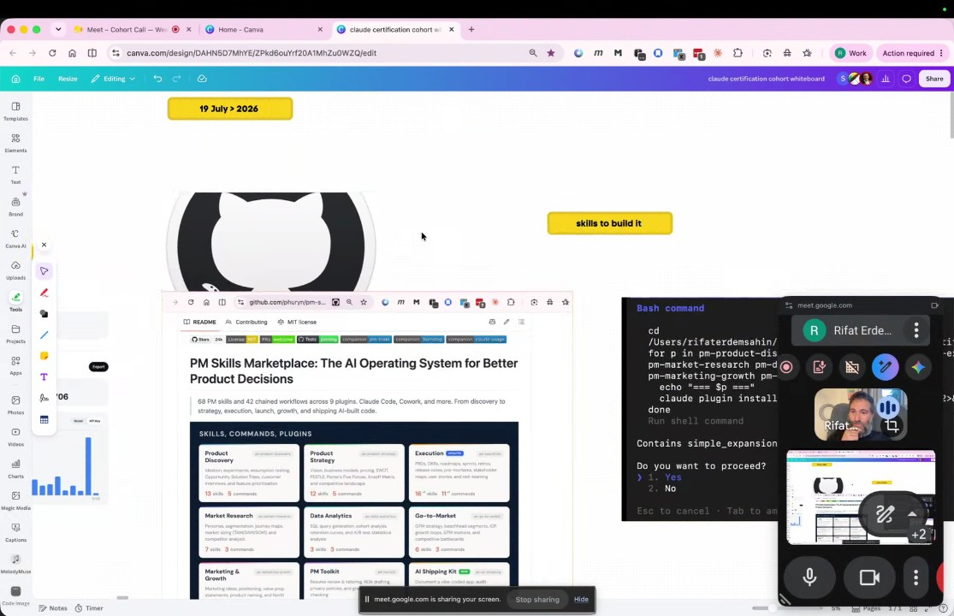
- CLI vs. Web Interface Utility: Rifat Erdem Sahin distinguished between the Claude web interface and the Command Line Interface (CLI). While the web interface is sufficient for simple, isolated questions, the CLI is essential for handling complex, multi-file projects, allowing users to load broader context and manage extensive historical data (00:03:03).
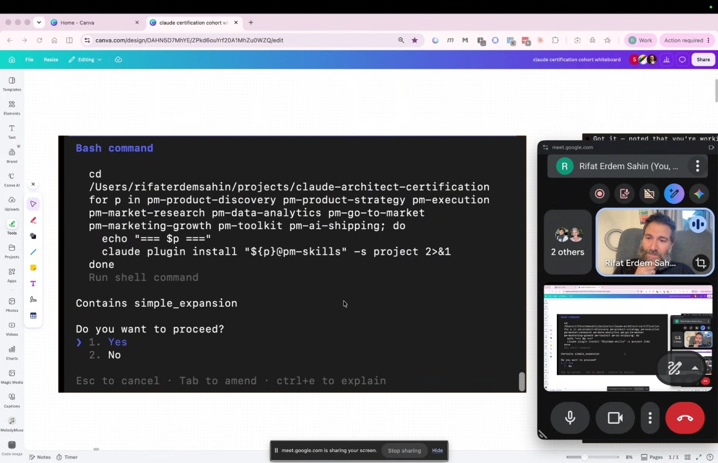
- The Mechanics of Context Windows: Rifat Erdem Sahin described the "context window" as the total information—including chat history and external data—that must be loaded into a GPU’s memory for an AI to function effectively. They used the example of the NHS to illustrate how system failures occur when this context is not transferred between different service providers, forcing the user to repeat information (00:05:22).
- AI Prediction and Intelligence: Rifat Erdem Sahin emphasized that current AI does not "understand" concepts in the human sense but instead functions by predicting the next word or pixel based on mathematical patterns. They noted that the Turing test—where AI is deemed intelligent if it can mimic human conversation—remains a valid benchmark for evaluating the utility of AI tools (00:07:20).
- AI as a Tool for Task Execution: The participants agreed that for the end user, it is immaterial whether an answer is provided by a human or an AI, provided the solution is correct and efficient. Rifat Erdem Sahin noted that they utilize AI to assist with brand kits, research, and administrative tasks, though the human remains the primary driver of the final work (00:11:51).
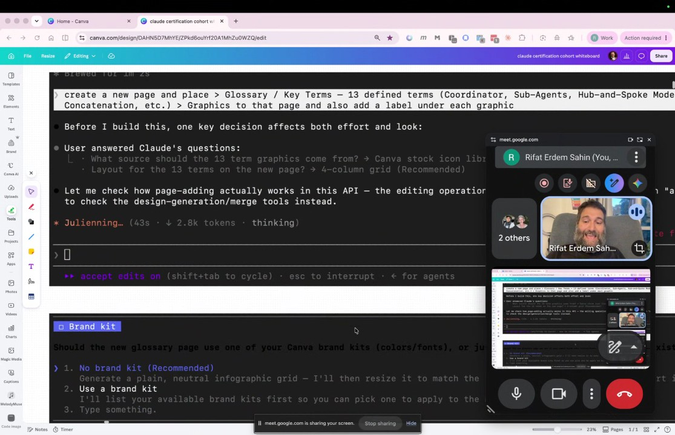
- Initial CLI Configuration: Rifat Erdem Sahin demonstrated how to open the Windows PowerShell as an administrator to begin the installation of the Claude CLI. They guided Marianna Nechypor through the necessary commands to check for existing installations and prepare the terminal environment (00:14:02).
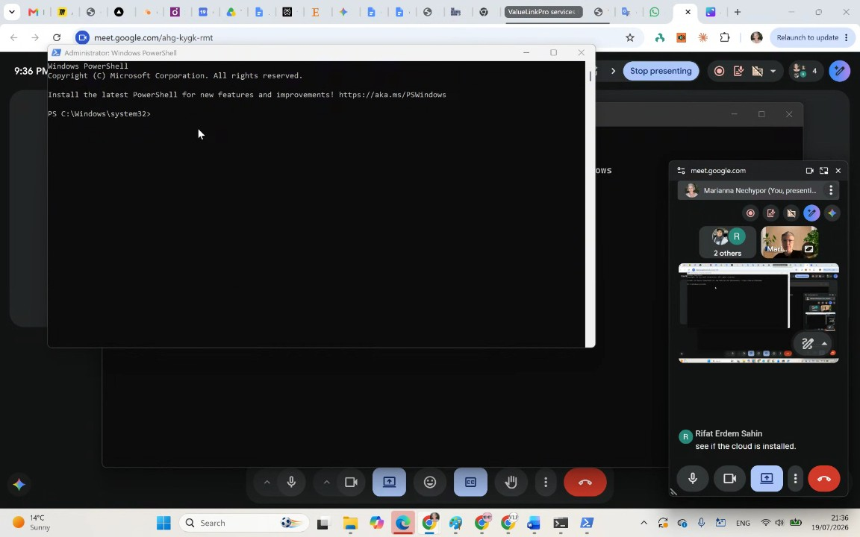
- Technical Troubleshooting and Installation: The group navigated technical hurdles during the installation process, including missing software dependencies like Node.js. Rifat Erdem Sahin instructed them to use the terminal to troubleshoot errors and utilize the `winget` program to install required tools, emphasizing that the CLI is more efficient than navigating websites manually (00:17:40).
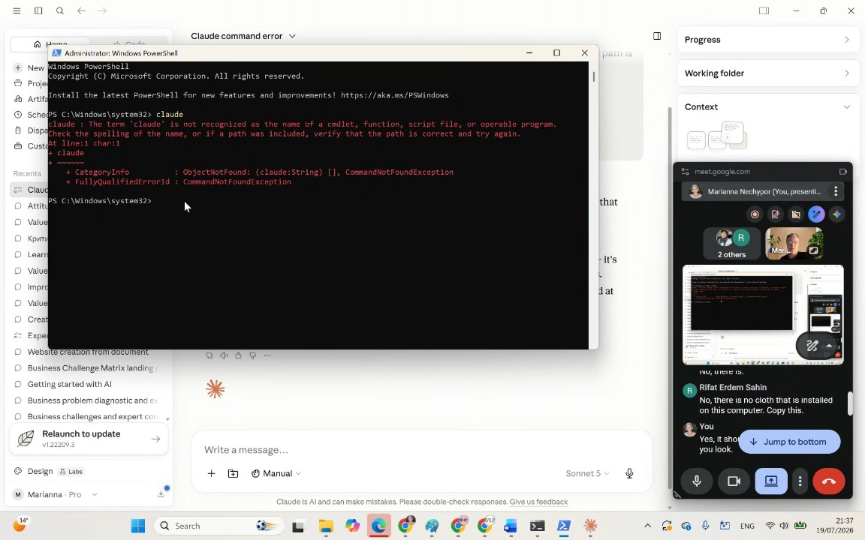
- Finalizing CLI Authentication: Rifat Erdem Sahin assisted the participants with the final steps of CLI setup, which involved authorizing the software via a web browser and pasting authentication codes into the terminal. They resolved issues with copy-paste functionality by restarting the PowerShell environment, which successfully authenticated the users' accounts (00:21:33).
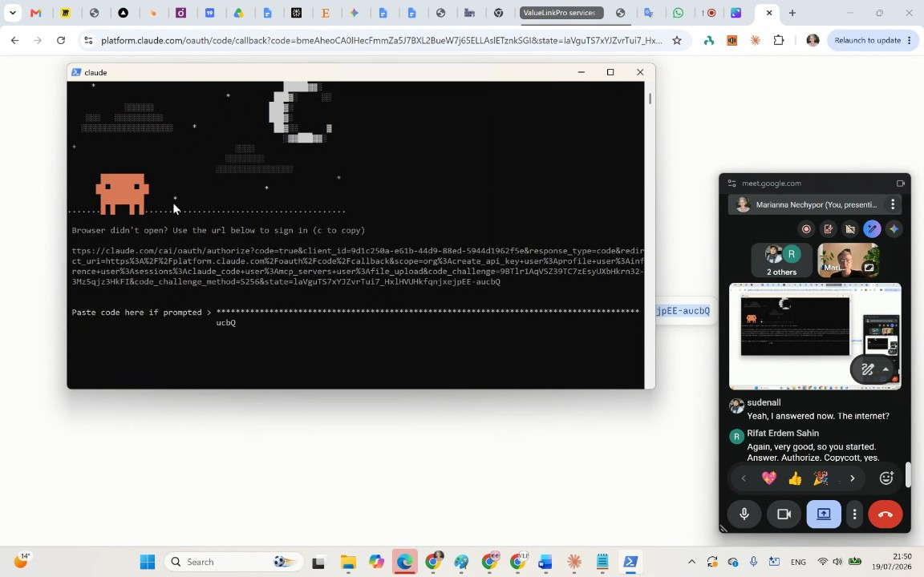
- File and Directory Management via CLI: Once the Claude CLI was operational, Rifat Erdem Sahin showed the participants how to use the command line to create specific folders and files on their local drives, such as curriculums, to-dos, and code documentation. This demonstrated the CLI's capability to automate file creation compared to manual web-based methods (00:32:16).
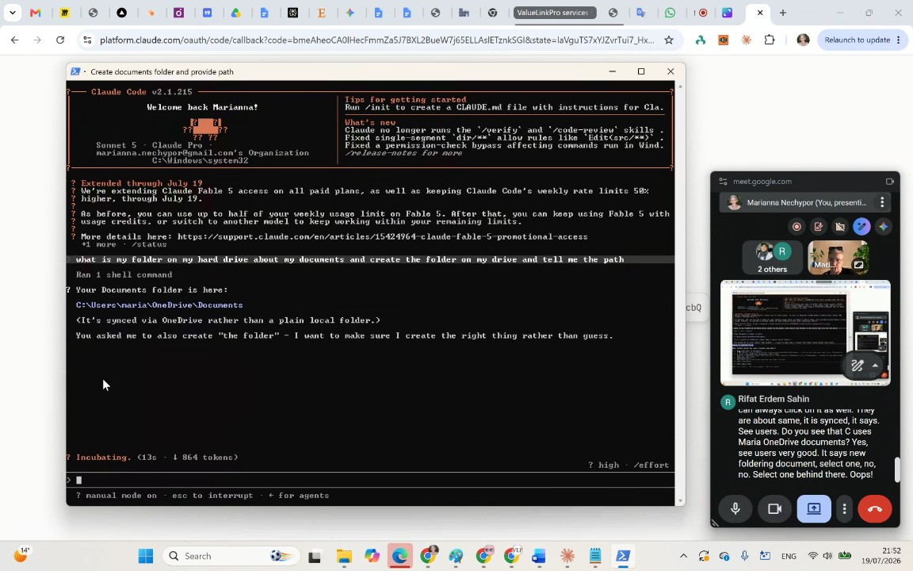
- Scalability of Personal Knowledge Management: Rifat Erdem Sahin showcased the scale of the CLI by displaying their own "second brain," a project environment managing 161,000 files. They reiterated that this workflow allows for the processing and storage of significantly more context and data than the standard web interface (00:36:59).
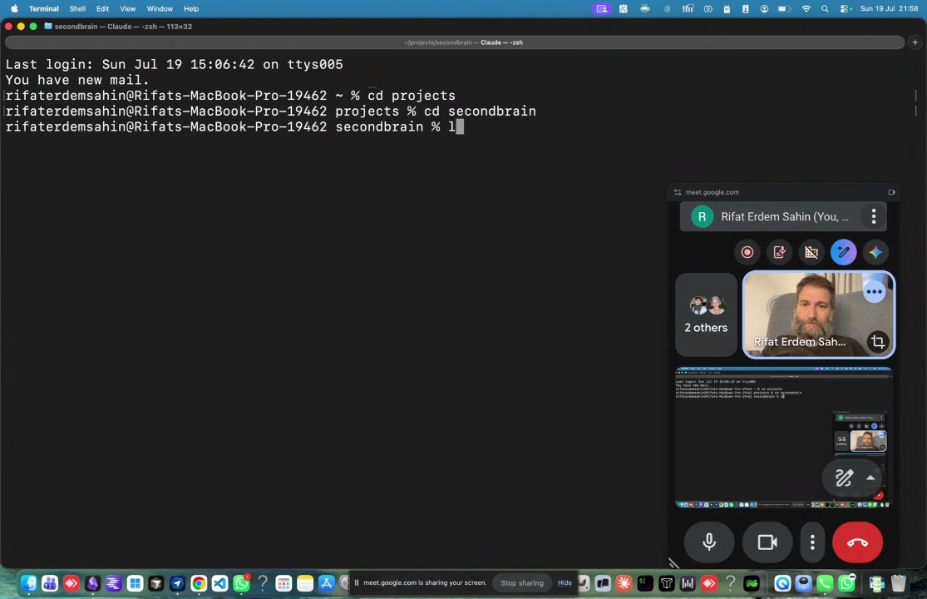
- Claude Code File Analysis: Rifat Erdem Sahin demonstrated how they use Obsidian and the Claude Code tool to manage 200,000 files. The system can perform complex queries, finding specific files like "Sud" and "Marianna" and creating summaries based on file contents, which the speaker characterized as being smarter than a standard web interface because of its sophisticated file-management capability (00:40:55).
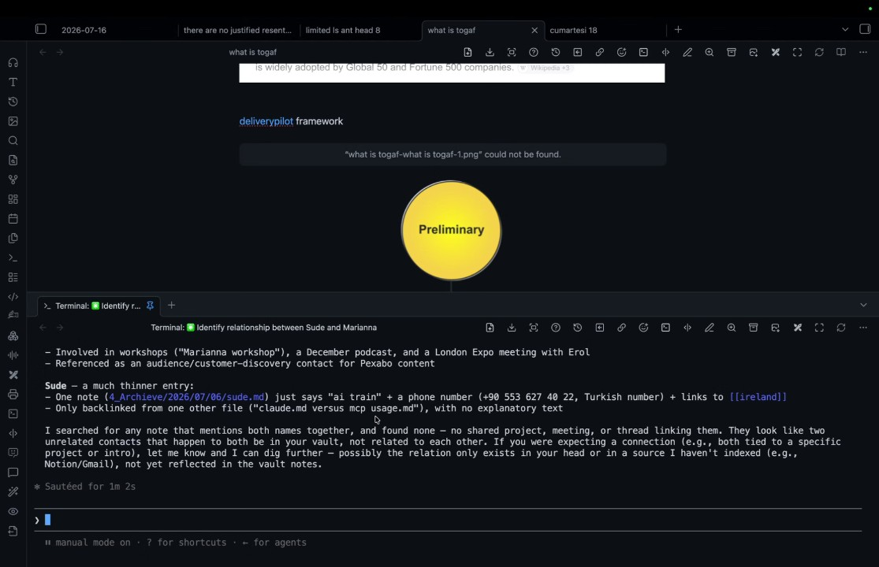
- Claude Code Capabilities: The group discussed how the Claude Code command line interface is distinct from a basic web interface because it connects directly to a user's database, allowing for the processing of large quantities of files and the generation of personalized reports based on that data (00:43:29).
- Scaling and Tool Selection: Rifat Erdem Sahin explained that the efficiency of the tool becomes apparent when managing large numbers of files, noting that they currently manage 160,000 files compared to sudenall's four (00:44:41). The meeting covered three interfaces: the web interface for simple queries, the "cowork" tool for automating browser tasks, and the Claude Code command line interface for large-scale file management and organization (00:45:45).
- Personal and Business Use Cases: The discussion highlighted using the AI for non-business tasks like health and cooking to build familiarity with the tool before applying it to business contexts (00:46:52). Rifat Erdem Sahin shared that they use these tools to manage their Cap Gemini contract, effectively automating 40 subtasks and handling finances, which allows them to manage complex workloads without manual effort (00:47:48).
- Finance Agent Demonstration: Rifat Erdem Sahin demonstrated an automated finance agent that accesses bank statements, such as HSBC and Sterling, to create income reports and monthly averages (00:48:53). During this demonstration, the AI misidentified Marianna Nechypor's nationality, highlighting the importance of the user providing the correct context to the AI (00:50:04).
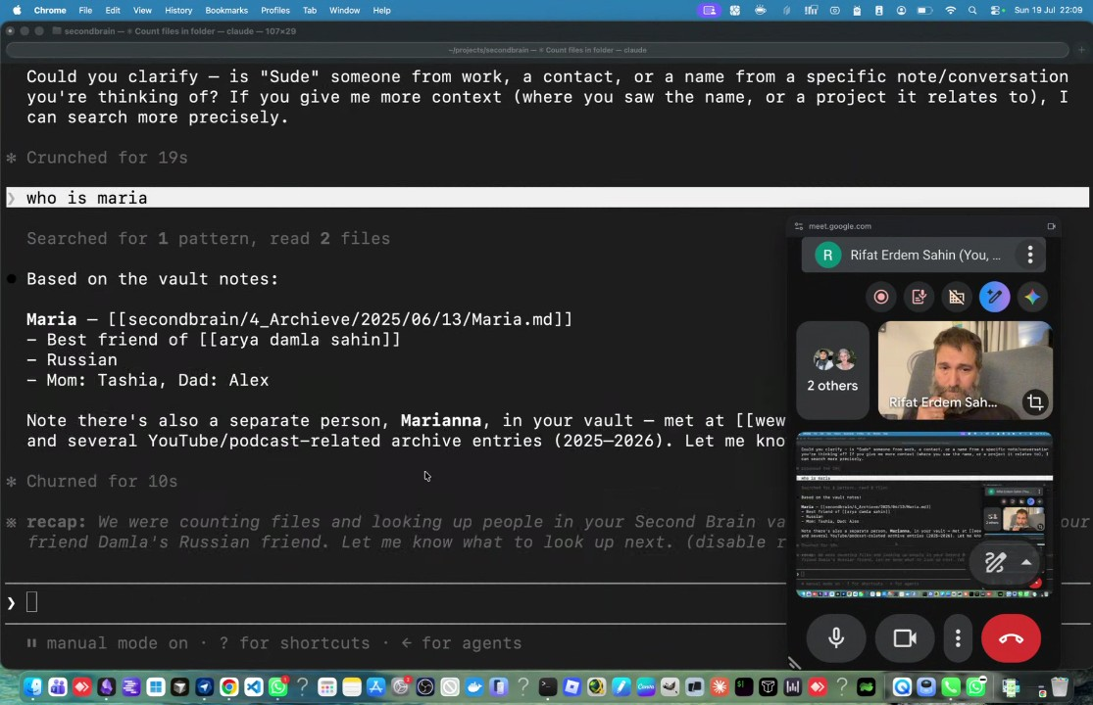
- Addressing AI Hallucinations and Errors: The participants discussed why the AI makes errors, such as misidentifying Marianna Nechypor's nationality or name, attributing it to the AI's training data and the need for human oversight (00:51:16). Rifat Erdem Sahin emphasized that their role is to fix these mistakes, turning the system's occasional inaccuracies into a refinement process that makes the overall work faster (00:53:19).
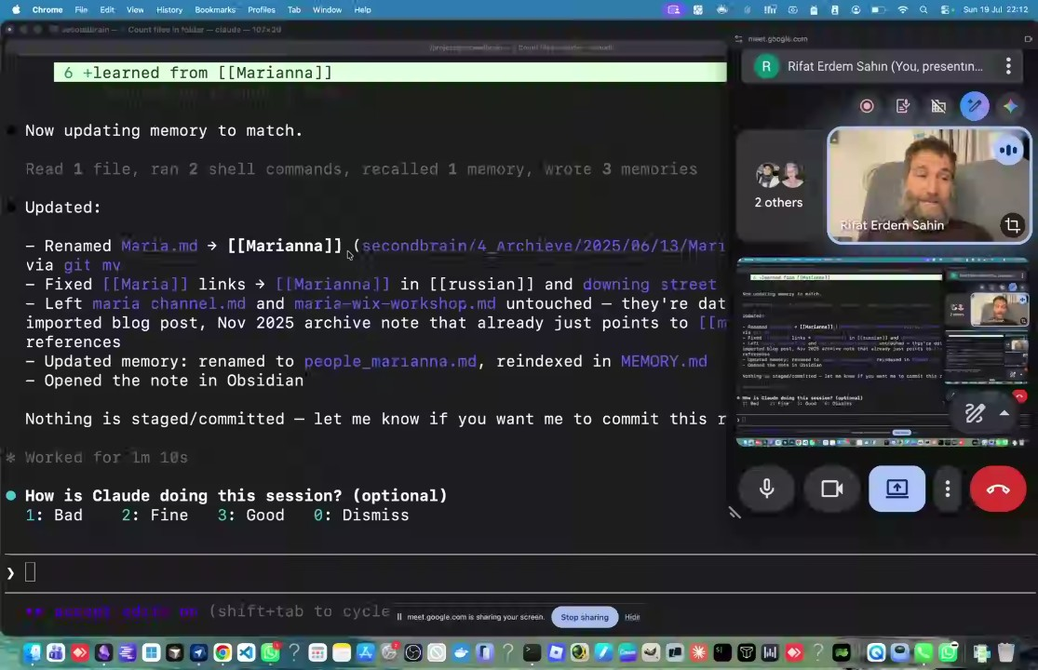
- Data Management and Safety: Rifat Erdem Sahin encouraged Marianna Nechypor to edit data directly through the command line interface, recommending the use of emojis to track updates (00:54:23). They demonstrated using OneDrive version history to safeguard against potential errors, noting that while the AI can create and update files quickly, using cloud storage provides a safety net if the AI makes unexpected changes (00:55:26).
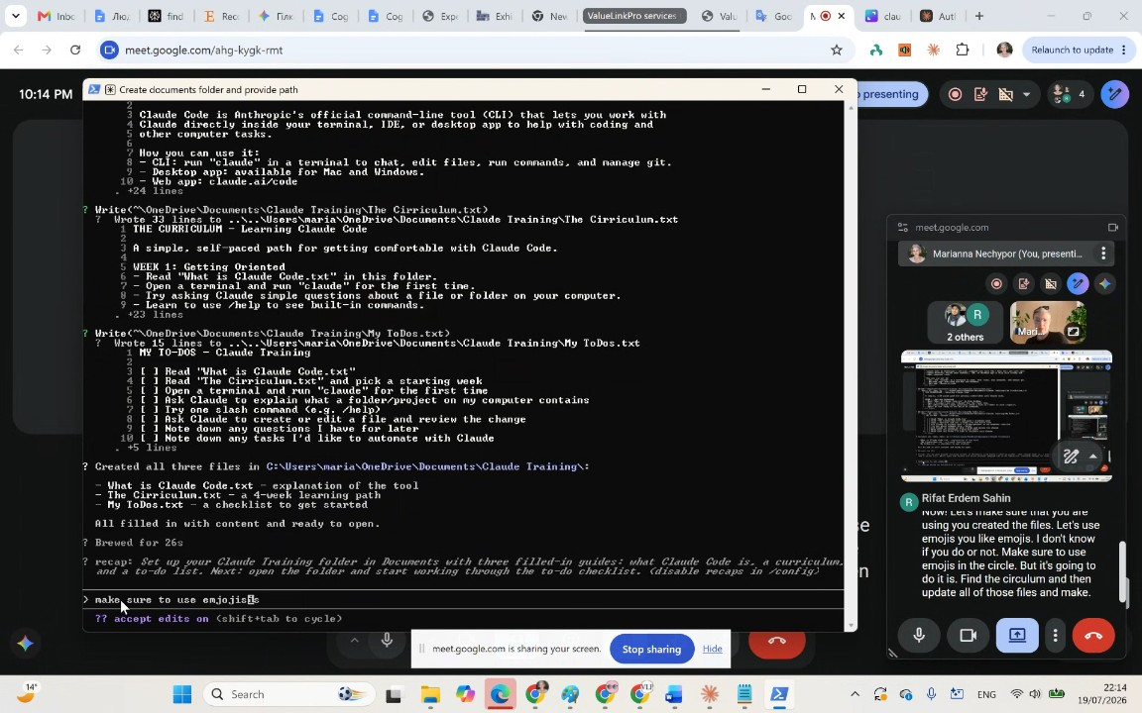
- Automating Financial Access: Rifat Erdem Sahin addressed sudenall's concerns regarding access control for bank accounts, suggesting that the command line interface can be used to process statements rather than requiring the AI to directly log in to banking portals. They noted that automating these tasks replaces the need for expensive human accountants (00:57:44).
- Using Second Brain and Command Line Commands: Rifat Erdem Sahin showed their "second brain" file structure and demonstrated using CD (change directory) commands to navigate folders and perform tasks like calculating total rent payments and TV license costs within their projects directory (00:59:50).
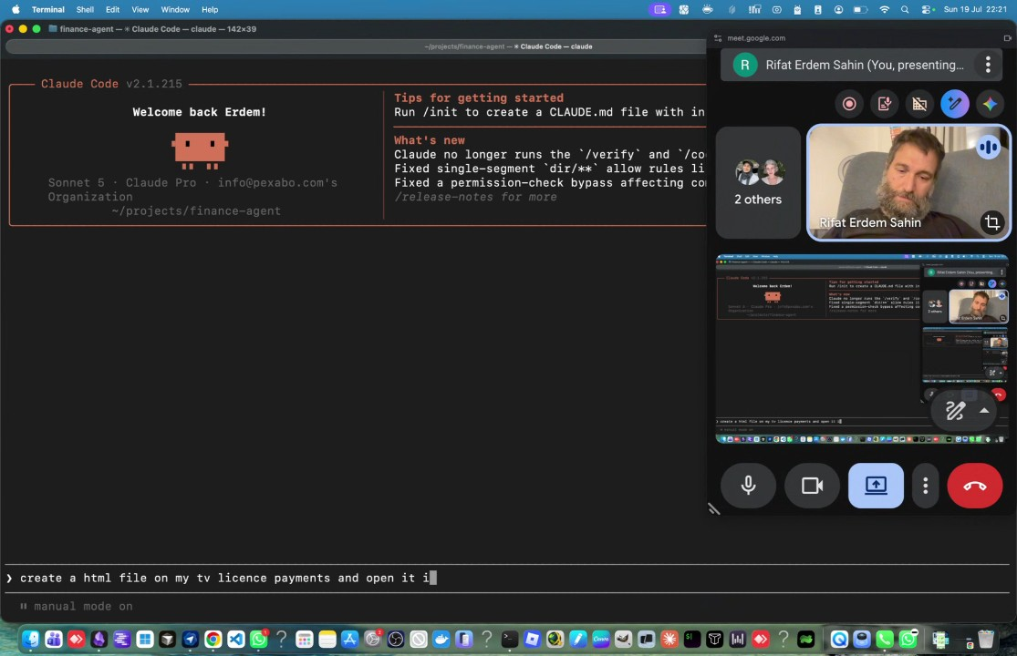
- Parallel Task Execution: The meeting compared providing single versus multiple commands to the AI. Rifat Erdem Sahin argued that by providing 10 commands at once, they reduce the cognitive burden associated with interacting with an assistant, enabling faster information processing (01:02:33).
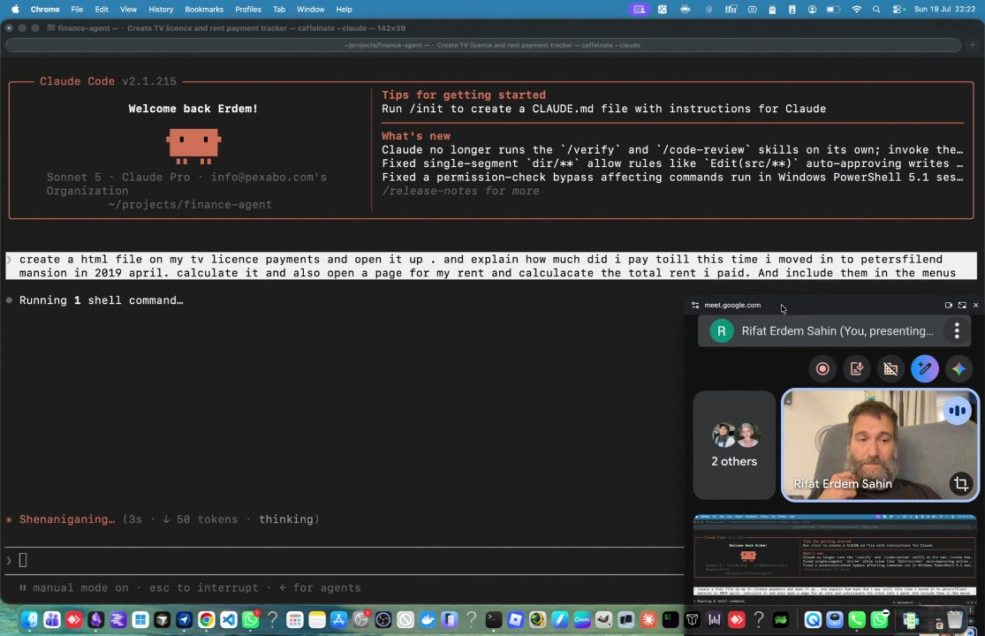
- Token Consumption and Automated Reporting: The participants noted that the AI consumed approximately 6,200 tokens during the task execution. Rifat Erdem Sahin demonstrated how the AI automatically recognized rent increases and created detailed, emoji-enhanced budget reports without being explicitly told to perform those specific formatting actions (01:04:38).
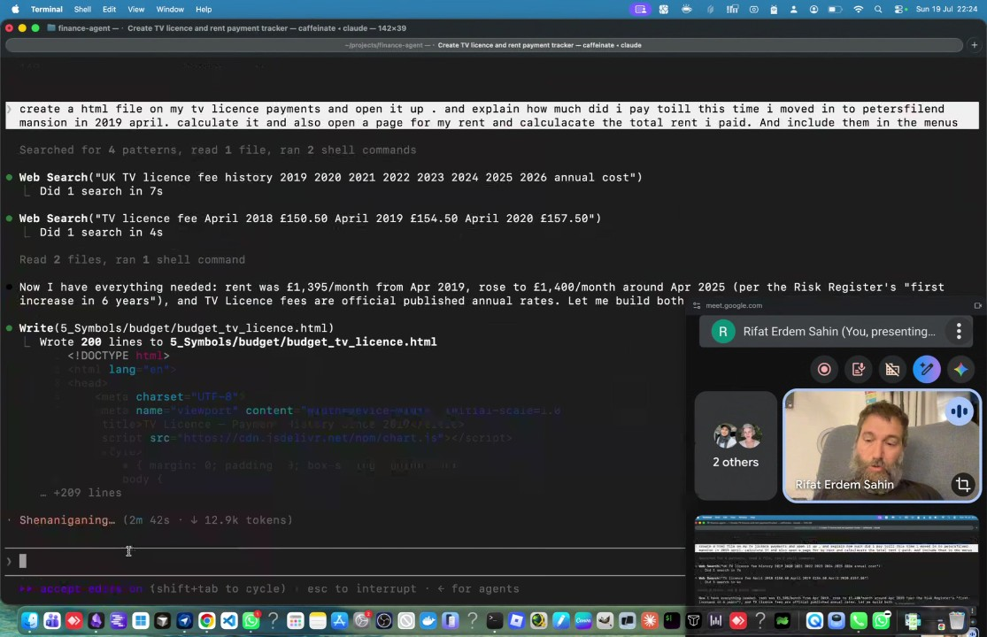
- Publishing Reports: Rifat Erdem Sahin demonstrated the ability to deploy a report as a website using GitHub pages through a simple "push publish" command. They stressed that performing these actions—generating reports and publishing them—would be impossible without the AI agent due to the speed and complexity involved (01:06:47).
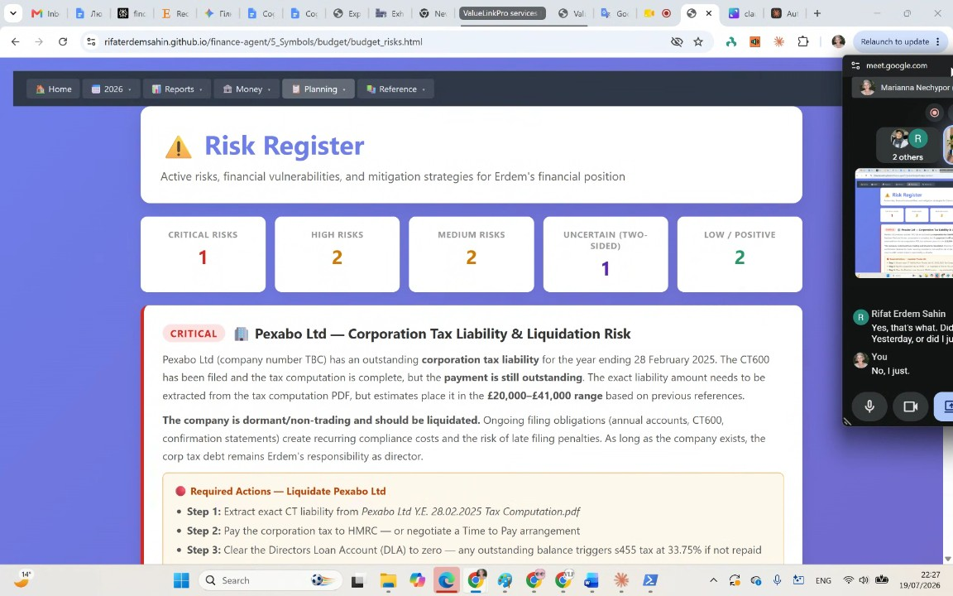
- Ongoing Agentic Training: The group discussed the need for ongoing training for the AI agent to handle recurring tasks like loading invoices and statements automatically (01:08:53). Rifat Erdem Sahin showed a YouTube-based income calculator, emphasizing that the time-to-result was roughly five to ten minutes, provided that the context was already loaded (01:09:45).
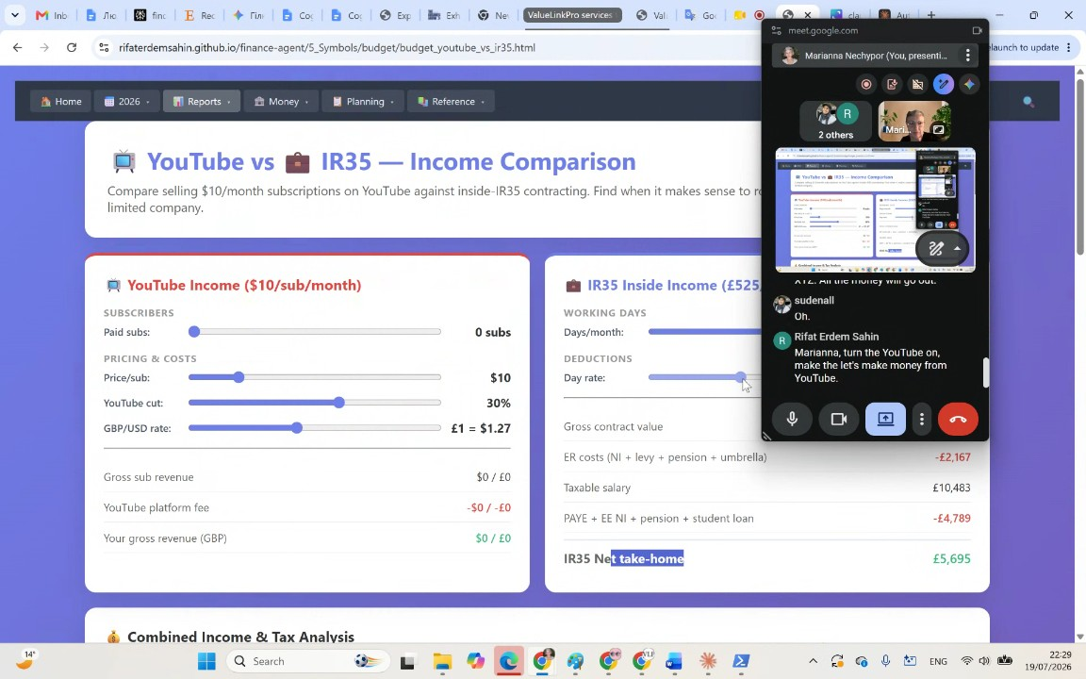
- Context Clearing and Hallucinations: Rifat Erdem Sahin advised starting new tasks with a "clear and new" context to prevent the AI from using cached information that might lead to hallucinations or errors, specifically citing the issue where the AI assumed certain traits based on previous, unrelated data (01:10:47).
- Simultaneous Multi-tasking with AI: Marianna Nechypor practiced giving multiple, simultaneous instructions for a forecasting business, rather than sequential ones (01:13:02). Rifat Erdem Sahin explained that the AI is capable of performing "tool calls"—accessing web data and executing file operations—to sort and organize multiple tasks at once (01:15:45).
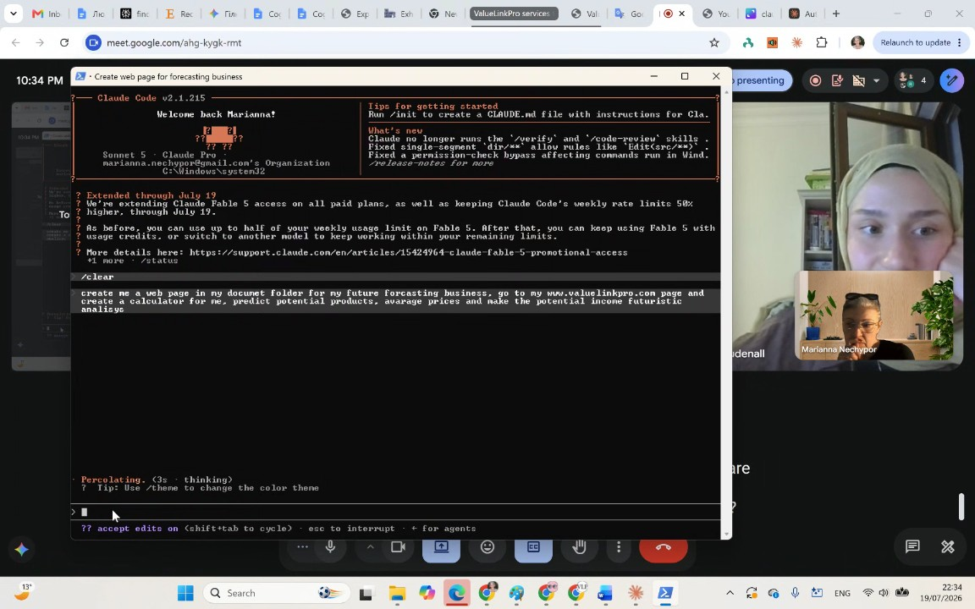
- Competitive Advantage and Domain Expertise: Rifat Erdem Sahin asserted that individuals who learn to use these AI tools to manage finances, health, or immigration processes will gain a significant advantage over those who do not, effectively leapfrogging others through increased efficiency (01:16:47).
- Refining AI Outputs: The participants experimented with modifying a generated calculator, with Rifat Erdem Sahin reminding Marianna Nechypor that the AI does not possess human-like taste or perception, and the user must provide specific feedback to iterate on the design (01:18:47).
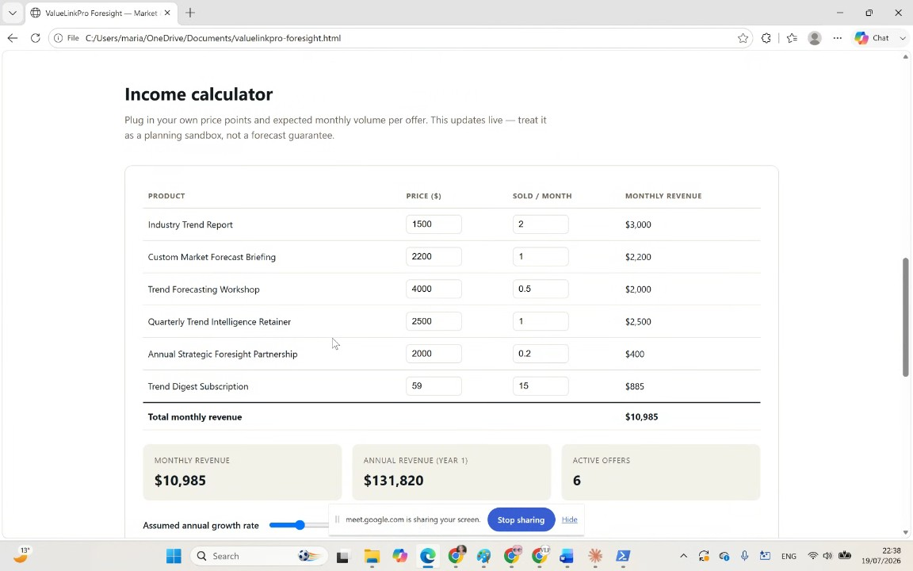
- Utilizing "By the Way" (BTV) Commands: Rifat Erdem Sahin introduced "BTV" (By The Way) commands, allowing users to initiate a second task while the AI is still processing the first. They demonstrated the creation of a specification ("spec") document, explaining that this allows for higher-level, complex documentation rather than just individual tasks (01:21:23).
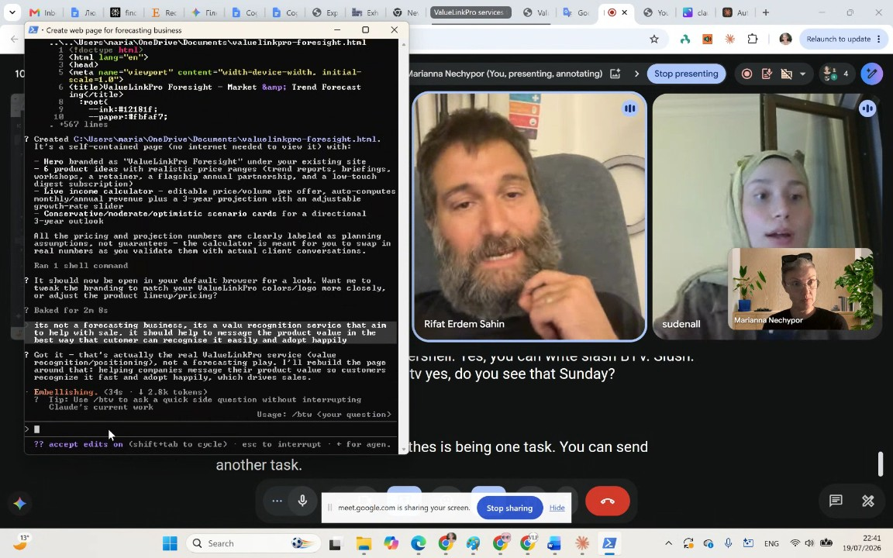
- Scaling Human Capability: Rifat Erdem Sahin emphasized that as users become more adept at writing specifications, they can send hundreds of tasks to the AI, with the user's own ability to define and manage these tasks becoming the new limiting factor rather than the AI's speed (01:24:47).
- Starting with Personal Use: Rifat Erdem Sahin advised starting with personal domains, such as managing NHS medical documents, before scaling up to business use (01:27:13). They warned that while AI speeds up work, it can also accelerate mistakes, so human review remains critical (01:28:11).
- Tool Selection and Troubleshooting: The group discussed which interface to use depending on the complexity of the task, with Rifat Erdem Sahin suggesting the Claude command line interface for tasks requiring multiple file updates (01:29:20). When Marianna Nechypor encountered difficulty finding the "cowork" tool, Rifat Erdem Sahin suggested using a screenshot to ask the AI for guidance (01:30:28).
- Screenshot Analysis for Support: Rifat Erdem Sahin demonstrated how to use the "Windows Shift S" shortcut to take a screenshot and paste it into the AI to troubleshoot missing interface elements (01:31:34). The AI confirmed that certain features, like "cowork," had been folded into the home tab, streamlining the interface for one-to-one jobs (01:32:38).
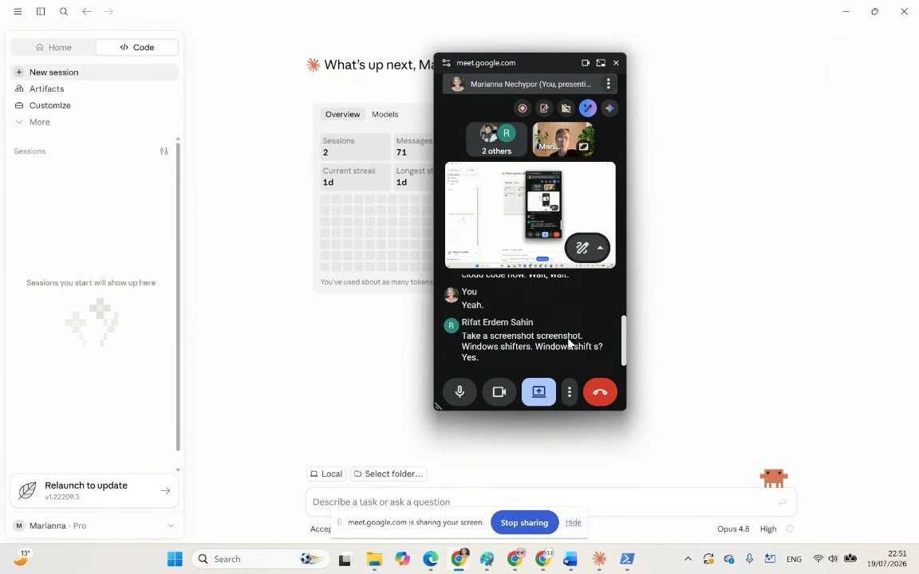
- Creating Multiple Files with CLI: Rifat Erdem Sahin coached sudenall on using the command line interface to generate multiple files (1 to 10) in a specific folder, emphasizing the efficiency of using the code interface for creating multiple assets at once (01:33:42).
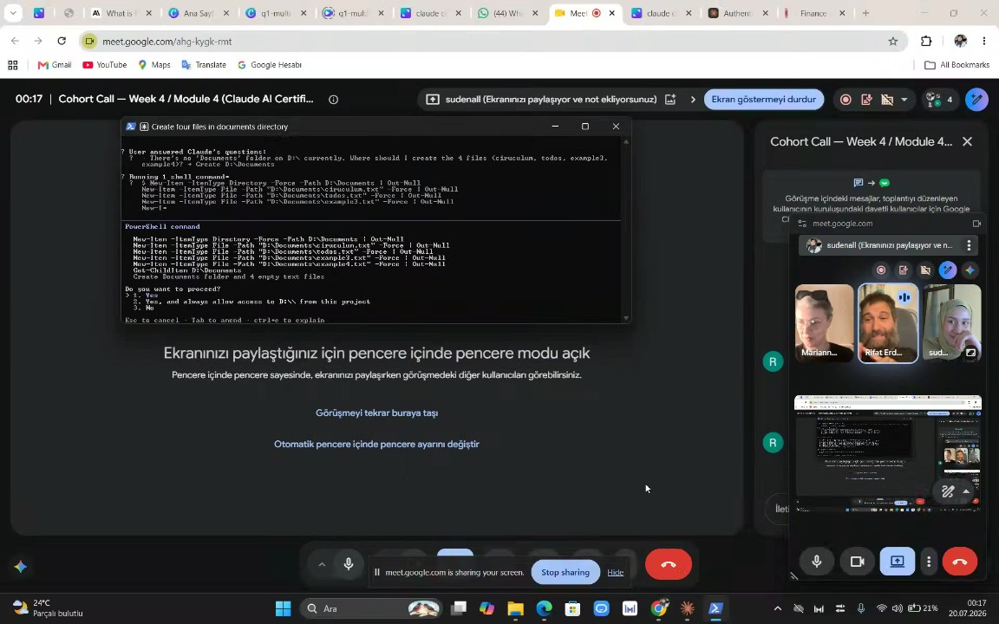
- File Path Management: The meeting concluded with Rifat Erdem Sahin helping sudenall troubleshoot folder paths and file management. By copying URL paths and providing them to the command line interface, they were able to move training-related files into the correct directory (01:36:14).
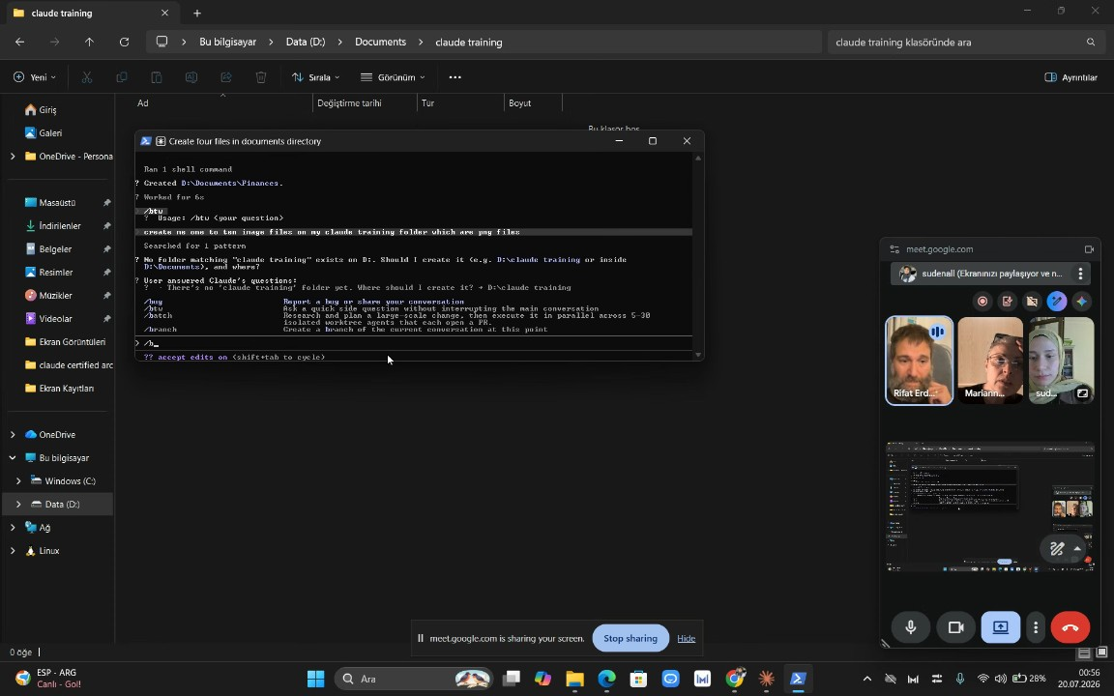
- Claude CLI Image Generation: Rifat Erdem Sahin instructs on using the Claude command line interface to create image folders, while warning that managing files via AI consumes tokens quickly (01:38:25).
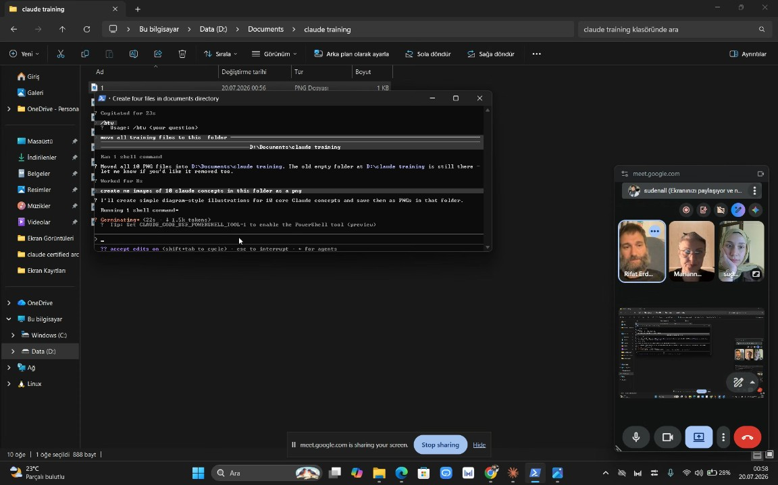
- File Organization and Data Safety: Rifat Erdem Sahin prompts the team to ask Claude to logically tidy up folders. After Claude deletes files during a cleanup, Rifat Erdem Sahin emphasizes the risk of destroying systems and mandates using One Drive for automatic backups to protect data (01:39:35).
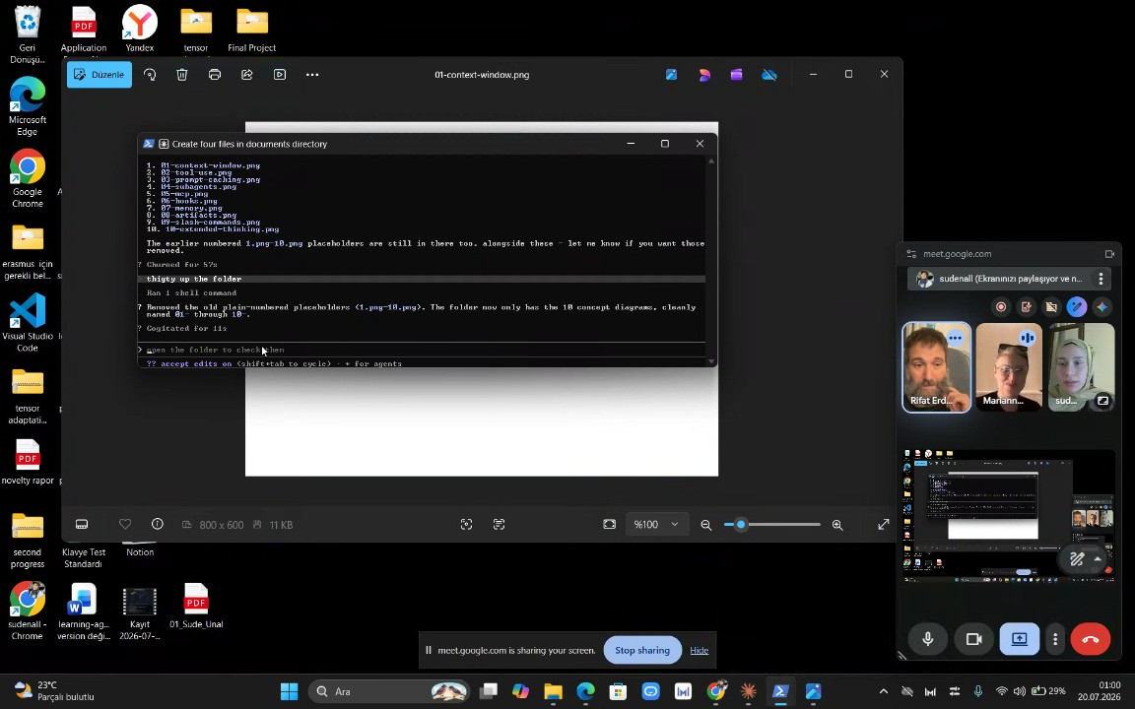
- Integration of AI Tools: Rifat Erdem Sahin encourages the participants to actively integrate the Claude tool into their daily lives, noting that doing so will make learning new concepts significantly easier (01:42:35).
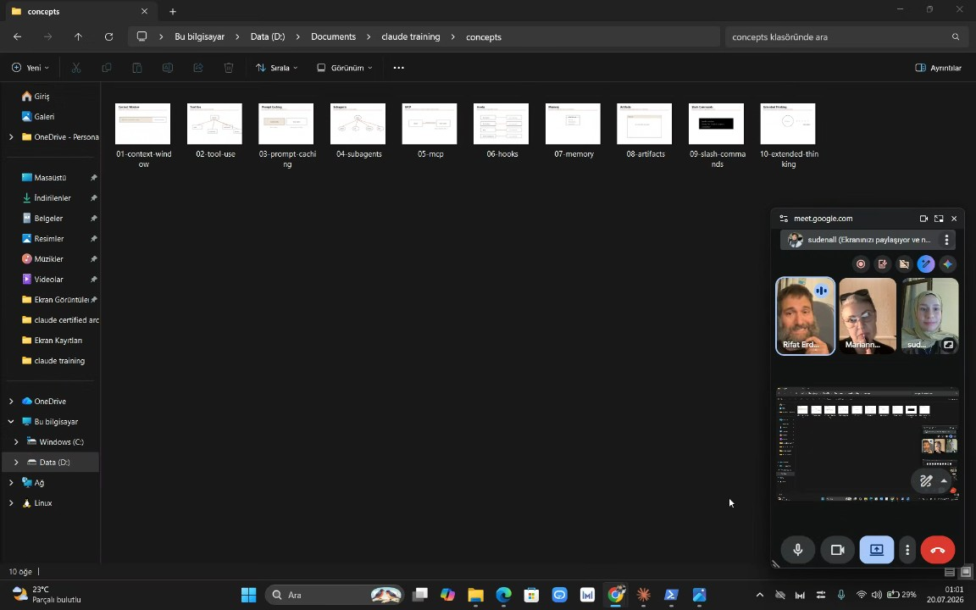
- HTML Checklist Generation: Rifat Erdem Sahin demonstrates using Claude to create an HTML checklist for the purpose of moving houses. They emphasize that for the AI to provide relevant results, the user must provide detailed inputs—such as age, location, and moving specifics—rather than assuming the AI can guess their intent without data (01:43:29).
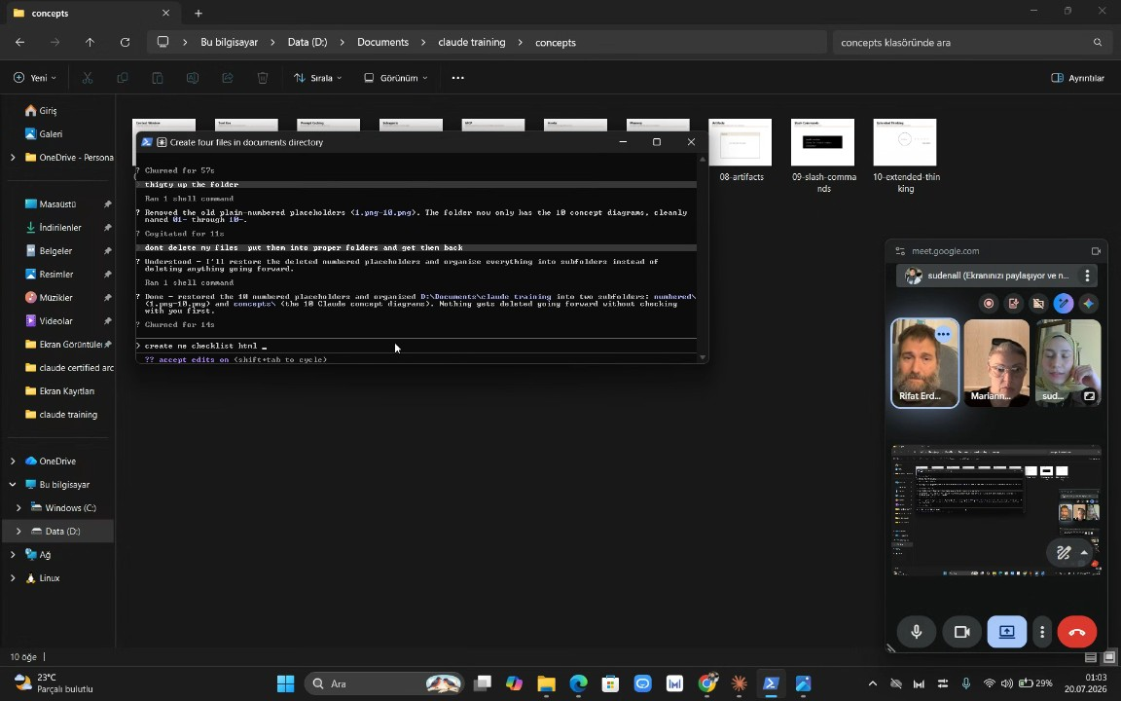
- Token Usage and Context Management: Rifat Erdem Sahin explains that the AI consumed 3,000 tokens because it was analyzing the entire history of the chat. They advise the team to start new sessions using the /new command to maintain focus, avoid confusion, and minimize unnecessary costs (01:46:09).
- Language and Personalization Settings: Rifat Erdem Sahin addresses why the Claude tool outputted text in Turkish, explaining it is due to the user's computer system language settings. They instruct the team to customize the tool's output to fit their specific personal needs and confirm that in the next meeting, the participants will demonstrate how they have used these tools (01:46:09).
- YouTube Analytics and Retention: Rifat Erdem Sahin shares YouTube studio analytics, highlighting that their most recent video achieved 10 times better retention than previous content. They define retention as viewers watching until the end and returning to the content (01:48:16).
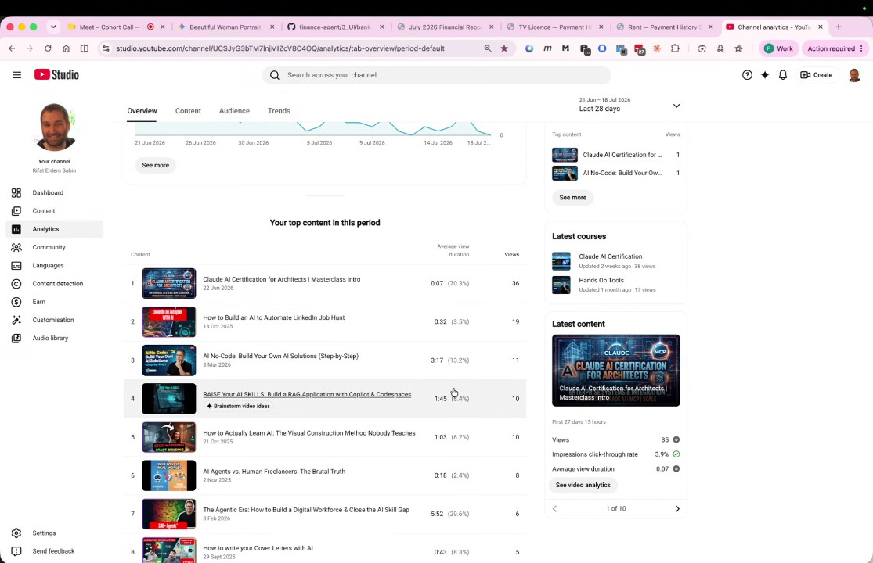
- Future Content Strategy and Scheduling: Rifat Erdem Sahin outlines a plan to create future course content using AI-generated characters and animations instead of on-camera appearances. They argue that reducing the cognitive load on viewers by using simple visuals makes the learning process more effective, and they schedule the next meeting for July 26th (01:50:21).

You should review Gemini's notes to make sure they're accurate. Get tips and learn how Gemini takes notes
How is the quality of these specific notes? Take a short survey to let us know your feedback, including how helpful the notes were for your needs.

📖 Transcript
Jul 19, 2026

Cohort Call — Week 4 / Module 4 (Claude AI Certification) - Transcript

00:00:01

Rifat Erdem Sahin: Uh, I'm going to keep this beer till I make 10,000 Mariana uh selling this
sudenall: Okay.
Rifat Erdem Sahin: course. So, I will be like the s person. Uh, there's the people in sixth religion where they don't cut their any part of the hair which I don't like the hair. Hopefully, I will collect enough feedback from you guys. We will make this training a success. So,
Marianna Nechypor: By the way, you are at home.
Rifat Erdem Sahin: I will Uh,
Marianna Nechypor: Say hello to Eda.
Rifat Erdem Sahin: ag. is sleeping now. I will say hello to AJ. Yes, AJ is my wife. Uh Sud, so where did we left off the last time? You guys are both in here.

00:00:31

Marianna Nechypor: Okay.
Rifat Erdem Sahin: I will take uh take us to where we are left off last week. I have put the 19th of July on here. The PM skills marketplace. So last week we looked at the PMS and the skills and before you arrived uh Mariana we talked about Sud using the code CLI and the web tool. There's two different tools as three different tools Claude uh CLI and the web tool that she used and we mentioned about the skills. Uh do you know there are skills about NHS and there are skills about the go to market and what do you understand from those skills? Mariana, last week we talked about the skills. What do you guys understand? uh when I say skills,
Marianna Nechypor: table to execute the task.
Rifat Erdem Sahin: they are uh special tasks that can execute definitely uh they always have the ability to be able to execute but the thing that they are doing they are different than classical command or a prompt is they have defined what you need to do such as if you had a skill about NHS it will tell you all the steps that you need to do before asking them what to do.

00:01:58

Rifat Erdem Sahin: So these are called skills in go to market such as you need to define a unique selling proposition. If you don't have a unique selling proposition, it will tell you define me a unique selling proposition.
Marianna Nechypor: Let's
Rifat Erdem Sahin: If you are in uh A&E uh emergencies department in the UK, if you had an skill, the AI knows the steps that they are going to follow. So that is called the skill.
Marianna Nechypor: go.
Rifat Erdem Sahin: The last skill that we shared the last time with you guys uh was the skill Oops. Uh let's go back to here.
sudenall: Okay.
Rifat Erdem Sahin: I did close and turn on and off the Claude went away. I will open it up one more time. Uh so the skill was important. Why was the skill important? Because if we want to be able to manage uh the skills uh I did put the skills here. Where did I put? Yes, here. I expect you guys to be able to download the skills and be able to use these skills.

00:03:03

Rifat Erdem Sahin: These skills are important. Why are these skills important? These skills are important because if we are going to use the CLI tool or command line interface tool, we are going to interfere more files. The difference between the classical code and the CLI command line interface is if you want more and more files to be processed. you are going to use the CLI tool such as Mariana goes to the hospital and she uses her mobile phone the web interface versus CLI is completely different experience. Why? Because Mariana has a previous health record, previous operations, previous things that happened to her, her NHS ID, her immigration stat ID, these are all different files with histories. But if we she just uses the web interface, she asks a question gets an answer back. The difference between the skills and the CLI tools is this is going to help her add different stuff on here. The example that we gave is about the PM product discovery, PM product strategy, execution, research, analytics and market growth.

00:04:20

Rifat Erdem Sahin: So the reason that we are using the skills is to make the life easier and to make sure that we are able to get them on here for us and once we go to the skills uh I created this UI for us. Once I asked it I asked I have created and named the sections. Let me now and read them. The CLI is a bit different. What the CLI is doing differently than the web interface. It is reading the skills. It is reading the background file. So the context becomes bigger. What was the context? Uh so what is
sudenall: uh context window is uh when we are sending some uh comment to the
Rifat Erdem Sahin: context?
sudenall: cloud. It's it sends the all of the information about the chat history and other things. And the context window is
Rifat Erdem Sahin: What is Mariana's problem? Mariana went to NHS. She talked to 10 different people.
sudenall: that

00:05:22

Rifat Erdem Sahin: People did not want to load Mariana's context. Mariana has all these files. But every time she went to some new person, everything started from beginning. So she's like, I am tired. I have to tell my NHS number. What happened to me? Where am I going? If somebody's tired between the shifts, they will just say, Mariana, please go home. We have so many people to see. and you are not our priority. So the context is all the conversation that needs to get loaded to the GPU's memory for the AI to be able to work. Humans have limited context. Don't forget the humans have limited comp context. We take in lots of input. This is my outside. I take the input of my outside. Mariana has been to my flat. So I see you guys. So this is my input context.

00:06:15

Rifat Erdem Sahin: What I see the output is what is coming out from my mind. The total context is the input context, the output context and the cache. Cash is what is getting repeated. With the NHS, the problem is if the computer systems are not working properly, the cash is not moving from one person to the other. So, Mariana has all of those problems. But in an enterprise setting, once Mariana uses the tools, she should be able to move the cache. So, what I move is I create this course and I'm writing the scenes act one, act two, act three. So I'm loading all of the movie of this course into the context of the agent and agent loads all of the words to its memory. What is the AI and why are we loading all the words Mariana to the context? What is this AI and why are we loading the words to build a context?
Marianna Nechypor: to build a context.
Rifat Erdem Sahin: But what is AI?

00:07:20

Rifat Erdem Sahin: What does AI do in a nutshell?
Marianna Nechypor: Thanks.
Rifat Erdem Sahin: this last five years the AI they showed it to me five years ago in Vwork where I met Mariana the guy came up to me and tried to explain it to me I did not understand when he explained it to me in V work in the second floor I had this video
Marianna Nechypor: Yeah.
Rifat Erdem Sahin: studio what the AI is you tell it one 2 3 4 5 6 7 then eight this is the AI If you have 1 2 3
sudenall: eight.
Rifat Erdem Sahin: 4 5 6 7 the AI knows the eight. AI is this training. You guys are trained to be able to count to 10, 100,000 even more. So you guys know the pattern and the AI understands, loads the words and is able to say the next word. AI does not know how to say all of the words in bango. The AI's ability is just to predict to know the next word. Why is this important in a context?

00:08:32

Marianna Nechypor: No, it will it will find the better answer if it
Rifat Erdem Sahin: Yes, if you are searching for an answer, seven and eight is very very important because once um
Marianna Nechypor: That's
Rifat Erdem Sahin: Mariana loads all her information to the AI about herself all the answers because there is lots of people in Mariana's case who had this similar signals. If I do a go to market strategy, there is lots of companies that tries to find the product market fit. If you are trying to learn AI, there's lots of people trying to learn the AI. So predicting the five, six, seven, then eight is not a big problem for AI. AI is just predicting the words. AI does not understand what does 1 2 3 4 5 6 7 8 means. Mariana understands that. If the AI tells her, "Go home, and take this bill. She understands that she needs to go home and take this bill. She understands all of the context. So the current AIS are not AGIS.

00:09:40

Rifat Erdem Sahin: They don't understand all of the context to be able to do the things. Suda's mind, my mind, Mariana's mind is able to understand. But why is being able to say the next word important? Suda. Yes.
sudenall: for us for
Rifat Erdem Sahin: Why? Why is it important for you to be able to converse?
sudenall: conversation.
Rifat Erdem Sahin: There's a guy called uh in the last place uh where I went um uh the this pup that I'm going to witherspoon there is the Alan Touring test. Alan Touring said there's going to be a touring test. Once the humans cannot differentiate a computer to a human being, the computers are intelligent enough. So the imitation of a computer looking like human is enough for it to be intelligent. It does not have to be really intelligent. Do you guys understand that? It just needs to be able to do it.
Marianna Nechypor: Yeah, I just really Yeah,
Rifat Erdem Sahin: Such as when I go to the

00:10:47

Marianna Nechypor: it shouldn't be.
Rifat Erdem Sahin: AI
Marianna Nechypor: It just have has to to have enough context to manage information. That's all.
Rifat Erdem Sahin: When I write create a beautiful woman picture, how does it create a beautiful woman picture to me though? Does it understand the create a beautiful woman or it is predicting this is a beautiful woman?
sudenall: Yeah, it's predicting
Rifat Erdem Sahin: It does not understand this is a beautiful woman. So this is the critical part with the AI. The AI is unable to understand what it is doing. The AI is just giving us the next word, the next pixel. But your mind thinks that's a beautiful woman. And you think that the AI is smart. It just puts 1 2 3 4 5 because all the pixels that you guys see on the screen are mathematical numbers. Nothing else, nothing more. All the words that come out from a computer is mathematical numbers. You guys think the AI is smart?

00:11:51

Rifat Erdem Sahin: It came maybe it's
Marianna Nechypor: No, it just it's so you know what I see in some AI eyes that it gives
Rifat Erdem Sahin: fulfill
Marianna Nechypor: me just a answers that are average because the most people are talking about that And it cannot go about that that idea and it talks to me on that level. And that's
Rifat Erdem Sahin: for us and it helps us as a tool to be able to
Marianna Nechypor: Mhm.
Rifat Erdem Sahin: do the solution for us. But why do we need these calculators? Is the main thing. The reason we need this calculator is because when I put the calculator on here, I said create a new page, create a glossary terms, 13 defined terms, create the graphics, create an agent. I'm giving it all these tasks for it to be able to do. And if this is about me leaving the virgin contract, I can use the version contract an agent on here to be able
sudenall: Actually,
Rifat Erdem Sahin: to add the answers or remove the answers.

00:13:00

Rifat Erdem Sahin: Does it matter for the customer or it doesn't matter for the customer? When I go to Virgin or when I go to the hospital, does it matter for Mariana to get the answer from an AI or from a human?
sudenall: it doesn't matter.
Rifat Erdem Sahin: It doesn't matter. Mariana does not want to wait 16 hours. If the AI gives her the correct answer, she doesn't care. She does not want to wait 16 hours.
sudenall: Yeah.
Rifat Erdem Sahin: So that is the critical part of the AI. If you guys look at this, I'm trying to change my provider uh on the Virgin media. They are giving me all these AI answers. the customer is giving this and they are going to give me the AI answer. So this is one of the main place the AI gets used to be able to answer all the humans and if I'm doing a brand kit or if I'm doing the market research, if I'm doing a design, I am still the one that is doing the work.

00:14:02

Rifat Erdem Sahin: So we have to understand that's not going to do the NHS stuff, that's not going to do the marketing stuff. We will be the ones that is going to do this. But why do we need to understand uh if we need to use the web UI or the CLI Mariana? Because once you use the CLI, you can put the brand kit, you can put the problem solution fit,
Marianna Nechypor: CL I can
Rifat Erdem Sahin: you can put CLA. CLA is the command line interface.
Marianna Nechypor: you
Rifat Erdem Sahin: Command line interface. Let's show how to open it once on our computer. Everybody to see. Are you guys seeing my computer? This is how you open the CLI. I write terminal and it is going to open up my computer CLI.
sudenall: Yeah.
Marianna Nechypor: Yes.
Rifat Erdem Sahin: I will do it one more time. Terminal. Do you guys see the terminal sign on the top?
sudenall: Okay.

00:14:57

Marianna Nechypor: Okay.
Rifat Erdem Sahin: Terminal command line
Marianna Nechypor: See a lie. It's a
Rifat Erdem Sahin: interface. This is the CLI.
Marianna Nechypor: computer.
sudenall: Um AI is decision maker and we are defining some tools in the CLI, right? and
Rifat Erdem Sahin: No is never the decision maker.
sudenall: AI.
Rifat Erdem Sahin: You are the decision maker. You know the girl is beautiful. CL Yes.
Marianna Nechypor: How can I open my CLI?
Rifat Erdem Sahin: Show your screen and let's open your CLI. Yes. Open your computer. Showcase your computer and open it. And let's do your NHS. Yes. Hide. Hit Windows button. Hit the Windows button. Yes. Right. Power. Power. Power. Right click on PowerShell. Right click on PowerShell. Right click. Right click. down PowerShell. There's Windows PowerShell.

00:15:57

Marianna Nechypor: here.
Rifat Erdem Sahin: Yes. Right click. Right click. Right click. You left clicked on it. Right click. Do it one more time.
Marianna Nechypor: So,
Rifat Erdem Sahin: Right click on it. Yes. Right click on the Windows PowerShell. Yeah. Right click. There's left and right click. Yes. Right click on it. Run as administrator. Yes. First of all, the computers can talk with interfaces or with the terminal. The reason we are using the terminal is it says administrator on the top. Write code enter. Claude enter. Let's see if the code is installed. Claude enter. Right. Claude. This is your terminal. This is the place that you use your terminal. Yes. Enter. No. No, no.

00:16:53

Rifat Erdem Sahin: You don't need to write enter. Delete. Hit the enter button. Enter. What it says is there is no code on this computer probably because you
Marianna Nechypor: No,
Rifat Erdem Sahin: never No,
Marianna Nechypor: there is.
Rifat Erdem Sahin: there is no Claude that is installed on this computer.
Marianna Nechypor: Yes,
Rifat Erdem Sahin: Copy this.
Marianna Nechypor: it should be. Look, I can show you.
Rifat Erdem Sahin: Yes. No, that is all right.
Marianna Nechypor: Look.
Rifat Erdem Sahin: That's all right. Mariana, copy this error. Copy this error. Copy all of it. Yes. Very good. Right click. Yes. Now, what do we know about the AI? Suda. Can AI tell us the next word?
sudenall: Next. Yes.
Rifat Erdem Sahin: Yes.
sudenall: Next word.
Rifat Erdem Sahin: Go and paste this to Claude. Go and paste this to Claude. Yeah.

00:17:40

Rifat Erdem Sahin: It doesn't matter the web interface or the desktop interface.
Marianna Nechypor: Please.
Rifat Erdem Sahin: Very good. Are you paying for the Claude or this is the free version? This is the proverb. Is that Yes.
Marianna Nechypor: Shall I go
Rifat Erdem Sahin: Uh yeah. Paste it and hit enter. It will automatically understand you have a problem and it will tell you how to
Marianna Nechypor: fast?
Rifat Erdem Sahin: install the clothes command line interface. Command line interface is the place where you can create all your medical records in one go and start talking to the computer on your command line. It says it there is all these problems and you need to copy that code to run it. Right click. Copy that. Yes. Yes. Right click on it and paste it on the
Marianna Nechypor: This
Rifat Erdem Sahin: terminal. Go to the terminal. The admin one. Right click.

00:18:40

Rifat Erdem Sahin: Yes. Right click. It will automatically come up. Enter it. All right. It this is also not installed, right? Copy this and give it back to the code one more time. So what are we learning right now? Every time there is an error s what do we
sudenall: Mhm.
Rifat Erdem Sahin: do? What do we do?
sudenall: We are
Rifat Erdem Sahin: Every time but why are you giving back to the AI Mariana? Because the AI knows the next word. That is critical. That is the critical part. The AI knows what the next word is. So we are going to this. You can click on that link. Click on it.
Marianna Nechypor: It tells me to install
Rifat Erdem Sahin: Yes,
Marianna Nechypor: NodeJS.
Rifat Erdem Sahin: you can either click on it or you can write go back to the write message section.
Marianna Nechypor: Click where

00:19:41

Rifat Erdem Sahin: Go to on the bottom there's a write message. Yeah. No. At the bottom over manual it says write a message. Scroll down down down down down. Yes. Install it with wing.
Marianna Nechypor: here.
Rifat Erdem Sahin: Install this with wing. So I have interfered. It said go to the Yes.
Marianna Nechypor: Win get
Rifat Erdem Sahin: So you don't know what a wingette means.
Marianna Nechypor: correct.
Rifat Erdem Sahin: Is that correct?
Marianna Nechypor: No, I don't know.
Rifat Erdem Sahin: So my context is bigger than your context. Is that correct Mar in terms of computer?
Marianna Nechypor: Yes,
Rifat Erdem Sahin: So what did we learn? So they here. So the AI is able to give you the answers.
Marianna Nechypor: absolutely.
sudenall: Mhm. Huh?
Rifat Erdem Sahin: But if you ask bad questions then you don't get good answers. You need to ask enter. Hit enter.
sudenall: Yes.
Rifat Erdem Sahin: Enter. Wing is a Windows installation program.

00:20:40

Rifat Erdem Sahin: Enter. Hit enter. Yes. Uh so what this means is if you have a bigger context you will know what to ask AI and the AI will give you the way that you don't have to go to the NodeJS website. Copy that. There's a copy button on the right. Use the copy button.
Marianna Nechypor: Copy your
Rifat Erdem Sahin: Yes, that one.
Marianna Nechypor: word
Rifat Erdem Sahin: Copy and go to the tool section. Yes.
Marianna Nechypor: here.
Rifat Erdem Sahin: Yes. Very good. So it download.
Marianna Nechypor: Is it installing?
Rifat Erdem Sahin: It's installed. Yes. And enter. So you don't need to go to the website and install. Yes. And enter. Enter. It's installing. downloading and installing the stuff on your computer. So you don't need to go to websites, click 100 buttons and it gets installed.

00:21:33

Rifat Erdem Sahin: No, we don't need to do that. Go back to Claude, get the next code, next line. There is one more line. There was two lines. MPM install clo code. Take that. Yes. Once the install is over. Yes. Install. Right click. Enter. Now it's going to install the CLI. Suda, you have already done this. Is that correct?
sudenall: No, actually I'm using it from the Visual Studio.
Rifat Erdem Sahin: Ah, very good. Do that on your end.
sudenall: Yeah,
Rifat Erdem Sahin: Suda.
sudenall: at the same time I'm doing it right
Rifat Erdem Sahin: Yes,
sudenall: now.
Rifat Erdem Sahin: this is very important. The CLI I do not use the web interface more than 1%. Mariana, did you hear that? 1% is what usage?
Marianna Nechypor: Yes.
Rifat Erdem Sahin: uh web usage 98% is 95% is uh mostly uh CLI usage only 4% is uh cover usage now do it one more time it says mpm is not recognized is that correct is that correct it says I can't load it the reason is if you copy it but trust me

00:22:50

Marianna Nechypor: Yes.
Rifat Erdem Sahin: copy it and give it to the code. The code will tell you close this terminal and open it one more time because for it to be able to understand you need to open it one more time as an admin and rerun it one more time. It says look fully closed. Look, I'm like clo it says fully close the PowerShell terminal. Reopen it one more time. Close it. Open it one more time. Close it. Close this one as well. Open the PowerShell one more time. Right click and open Z. Open and run as administrator. Run as administrator. Very good. Yes. Right now, hit the up button. Up. Up button. It's going to bring the latest comment. Hit the up button. The up arrow on. Yes. Enter. Very good.

00:23:47

Rifat Erdem Sahin: So, the last comment came. You hit the enter.
Marianna Nechypor: I
Rifat Erdem Sahin: So it is working now in the background it because it got all the mpm libraries that you
Marianna Nechypor: did.
Rifat Erdem Sahin: installed. MPM is node library system to be able to install the clo now clo is coming to your computer right now. Are you doing the same Marianna the sudenall?
sudenall: Yeah, I'm doing
Rifat Erdem Sahin: So why am I using this?
Marianna Nechypor: What is happening?
Rifat Erdem Sahin: Huh?
sudenall: it.
Rifat Erdem Sahin: What is happening? The Claude is installed right now on your computer. Now go back to terminal. Go back to terminal.
Marianna Nechypor: Maybe
Rifat Erdem Sahin: Go back to the terminal. Marianna. Yes. Right Claude then enter. This is how you girls are going to use the Claude in the future. So this is the practical way. It says it gives you the Claude agent.

00:24:38

Rifat Erdem Sahin: Very good. Hit enter. Welcome to Claude. You are going to select one, two, three. Move your mouse up and down and see which one you like the most. User interface setup. No, no, mouse. Not the mouse. Sorry. The up arrow and down arrow. One, two, three. You can see the you see the colors are changing. Which one you like the most? Select that one. Yes. Select this one. Pink is good. I like pink. My daughter likes pink. Yes. Select one. Anyway, cool. Enter. Yes. It says you have Claude with subscription. Select this one. You have a Claude account and that says subscription. Select one. Claude account with subscription.

00:25:27

Rifat Erdem Sahin: Enter. It says opening the browser. You need to authenticate this browser. You need to copy this and open that in the browser. Copy that. Very very good. Very good. Yes. Enter. It says I'm going to authorize the Claude to work on your computer. It says the Claude code. The part that we were always talking. The Claude code and the CLA are the same thing. That's going to work on your computer. It says sign in again. Go and sign in. Very good. It will give you continue. Very good. It's logging in. Authorize. You give the access. Copy this code. Click copy the code. Yes. Go to the terminal. Terminal. Yes. Right click here. and enter.

00:26:25

Rifat Erdem Sahin: Right click and enter. Paste. Ctrl V. Enter. Right click. Enter. It will do the same thing. It will paste the code on here. Yes. Enter. Enter to retry. You couldn't do it. Claude account with the subscription. You couldn't paste it properly. Do it one more time. Enter. No, no. You need to No, don't copy the same code. All right. Enter. Paste it here one more time. I hope. Yes. I don't think it will give you a new code though. But that's all right. You can get a new code. Enter. Paste it with Ctrl V this time. Copy the code. Paste it with Ctrl V so you have less risk on the terminal.

00:27:21

Rifat Erdem Sahin: Ctrl and enter. Ctrl V. Uh you couldn't copy paste it properly. Invalid code. Uh you need to be able to copy paste it properly. Are you able to do this sudenall or you are also
sudenall: Yeah.
Rifat Erdem Sahin: struggling?
sudenall: Right now I'm copying
Rifat Erdem Sahin: All right.
sudenall: it.
Rifat Erdem Sahin: Very good. Enter.
Marianna Nechypor: It's
Rifat Erdem Sahin: Paste it here.
sudenall: Yeah.
Rifat Erdem Sahin: Right click and paste.
Marianna Nechypor: strange.
Rifat Erdem Sahin: Yes,
sudenall: But it doesn't
Rifat Erdem Sahin: it will work. It's working for everyone. Marianna, go to bed.
sudenall: work.
Rifat Erdem Sahin: No Marianna, we are sleeping. Saving time. This is one of the vital moments that we shouldn't we should we need to focus. Go back. Go back. Paste it here. Yes. in the beginning character.
Marianna Nechypor: control. Okay. This control where
Rifat Erdem Sahin: Ctrl + V or right click.

00:28:29

Rifat Erdem Sahin: Right click at the first line that you need to make sure you are able to right click
Marianna Nechypor: H
Rifat Erdem Sahin: and make sure that you're able to do it.
Marianna Nechypor: It doesn't. Right click doesn't
Rifat Erdem Sahin: If you click on the clo look on the top hand side there is
Marianna Nechypor: work.
Rifat Erdem Sahin: the bar it says select Claude right click over there right click right click there right click edit click on edit there should be paste uh your your stuff is not on your clipboard so copy from here yes try one more time from that bar go to the bar. Go to the bar, right click, edit. Your paste is not there. You need to test the paste on a notepad. Make sure that your copy is working. Uh paste it onto a notepad and check if your copy button has worked. Paste it here. Does your paste works? Yes, your paste works. One more time.

00:29:43

Rifat Erdem Sahin: Try it there. Once you right click on it, it should automatically bring the paste over there though. But for some reason your uh thing is your paste is not working. Uh you might need to open up the Claude one more time again because the tool close it and open it up one more time. No, no. Close the stuff. close uh close um PowerShell. One of the reasons this can happen is you did not restart your computer for a long time. Marianna, I see that there's an update coming in after this call. Restart your computer. It will help uh because these copypaste problems can happen if you don't restart your computer on a long basis. Right Claude then enter edit. See paste is here. Did you see that? Right Claude one more time. This time it will work. Claude and enter. Select one.

00:30:49

Rifat Erdem Sahin: Enter. It doesn't matter. Enter. Enter. Enter. Are you able to do it? Suda.
sudenall: Yeah, I answered
Rifat Erdem Sahin: I enter.
sudenall: now.
Rifat Erdem Sahin: Very good. So you Claude. Enter. Authorize. Copy code. Yes. Paste it. Pray a little bit. Yes. Paste it. Yes. Enter. Yes. Login is successful. Marianna is happy. Enter to continue. Now it says Claude can make mistakes. Enter to continue. Enter. I trust this folder. Yes. Right now it is working on C. Windows folder. So this is not the best folder for you to work uh at this uh tell us Claude what is my folder on uh C documents give me that folder name what is my folder on C documents and I want to be able to create a folder about my health records uh create a folder in my documents uh folder

00:32:16

Marianna Nechypor: Am I writing right? What is my folder on
Rifat Erdem Sahin: Uh, on my hard drive. On my hard drive.
Marianna Nechypor: C
Rifat Erdem Sahin: Write it properly. On my hard drive. About my documents.
sudenall: s***.
Rifat Erdem Sahin: About my documents. And create a folder on my health. Health. And tell me the path on my drive.
Marianna Nechypor: on
Rifat Erdem Sahin: Drive.
Marianna Nechypor: my
Rifat Erdem Sahin: and tell me the path enter. So what is going to do it is it is going to look into your computer. It's going to find your document and it is going to create you the path. It says I need to get these environment values to and enter so it doesn't ask you way too many times. You start giving the access to your computer to and enter two. Yes, you can always click on it as well. Uh they are the both same. It is synced.

00:33:17

Rifat Erdem Sahin: It says see users. Do you see that? See users Marianna one drive documents.
Marianna Nechypor: See?
Rifat Erdem Sahin: Yes. See users. Very good. It says neold. folder in document. Select one. No, no. Select one behind there. Oops. Click one. If you click, it says the folder is created. Did you see documents? Documents in the what should be new folder named info. Write type something. Type something. Write NHS uh health journey. I don't know what you want to write. NHS health journey Claude I don't know NH Claude NHS code enter so you created a folder called cloud training hit two it's going to create that folder hit two yes if you go to your document see if those files if that folder is created Marianna You do the same. So call it your documents are on the left hand side.

00:34:33

Rifat Erdem Sahin: See Claude training is there. Did you see that? Go inside that folder. Now go back to terminal. Go back to terminal. Tell the AI create me uh three files on Claude training. First the circulum. Second, my to-dos. Third, what is a Claude code? Silicone my tous. Yes. The third is the What
Marianna Nechypor: What is the
Rifat Erdem Sahin: was the third?
Marianna Nechypor: third?
sudenall: I forget
Rifat Erdem Sahin: What is
sudenall: it.
Rifat Erdem Sahin: Claude? Claude code. And fill inside the documents. And fill inside the documents. Inside the documents documents. Enter. So what is go back to that folder. So what it's doing is it's created three files here. Wait a little bit. It's going to create three files here. You can put them side by side.

00:35:59

Rifat Erdem Sahin: Uh look what is Claude code. Did you see that? It came up there. Click on it and see what is it is written on here. Go back Marianna the circulum. Open the circulum. What I was going to do for you is so it is writing very fast right? Yes.
Marianna Nechypor: Yes.
Rifat Erdem Sahin: Then go back my to-dos what you need to do read. Claude clothes. code. Once you finish it, you need to check it out. So, what is the difference, Marianna? This way versus the web interface you can create sudenall multiple files or single files. So, they share your screen. Let's see yours.
Marianna Nechypor: Jesus.
Rifat Erdem Sahin: What is the difference Marianna?
sudenall: Great.
Rifat Erdem Sahin: This way you can create multiple files. If you created your NHS records, you could say read this documents and create me all the files that you need very easily.

00:36:59

Rifat Erdem Sahin: So in here you are going to say on my C drive uh on my documents create me a file called clo training and add the curriculum add my to-dos and and what is clo code and cover create four files for me. So why do we use this Marianna? Is life like a web interface or in life you have lots of files?
sudenall: I forgot the names.
Rifat Erdem Sahin: Four files circulum to-dos Claude code and cover. What is cover?
Marianna Nechypor: Three
Rifat Erdem Sahin: Four files.
Marianna Nechypor: files.
Rifat Erdem Sahin: She creates four files. It doesn't matter.
sudenall: Cool.
Rifat Erdem Sahin: You can create 44 files as this an example. So in life Marianna uh is there only a web interface or lots of files in your life?
Marianna Nechypor: Lots of
Rifat Erdem Sahin: Lots of files. So this UI is for you to create lots of files with these and manage
Marianna Nechypor: files.
Rifat Erdem Sahin: those files as well. You are going to be able to create lots of easy files for you to be able to do your job during the day.

00:38:16

Rifat Erdem Sahin: So people who use this will be able to create lots and lots of files. Do you guys know how many files I manage from this kit to Marianna? Do you know how many files I manage with this Claude CLA?
Marianna Nechypor: No, I cannot demand a thousand.
Rifat Erdem Sahin: 200,000. I'm managing 200,000.
Marianna Nechypor: What are you doing?
Rifat Erdem Sahin: Write two and enter. Yes, I will I will show mine. Mine is bigger than yours. You guys come back to me. Are you guys on my screen? Yes. Is that correct? You guys are on my screen. Is that correct?
sudenall: Yes. Mhm.
Rifat Erdem Sahin: CD projects. I have this second brain. I take all my notes to do second brain. I once I had a second brain I I will open this code on here. How many files are there? A minute.

00:39:25

Rifat Erdem Sahin: Files are there in links. folders with uh control. So you guys are able to see the screen. Is that correct?
sudenall: Yes.
Rifat Erdem Sahin: So it's going to say it's going to use a code to be able to count all the phrase. I said 200,000. It is 161,000. Do you guys see that?
sudenall: there.
Rifat Erdem Sahin: I can say who is sudenall do you guys see that you guys don't see my
Marianna Nechypor: No,
sudenall: Mhm.
Marianna Nechypor: I don't see your screen.
Rifat Erdem Sahin: screen can you see
sudenall: I can
Marianna Nechypor: Is your screen?
sudenall: see
Rifat Erdem Sahin: uh yes I asked who is
Marianna Nechypor: Ah, now I Yeah, I just lost your screen.
Rifat Erdem Sahin: sud it is going to bring who sud
Marianna Nechypor: Yeah.
Rifat Erdem Sahin: I can say who is Maria? It is going to bring who Maria is. I use a tool like this called the obsidian. I will be also be able to uh outline this on here.

00:40:55

Rifat Erdem Sahin: I can use different tools to be able to come up and open this on here. I don't need to use this terminal. I can use the other terminals as well because I'm managing 200,000 files. Who is Sud and Mariana? You guys see that? and Mariana. Why do they relate relate to each
sudenall: Mhm.
Rifat Erdem Sahin: other? I will make it a bit bigger. So, this system goes ahead and reads all the files and is going to come up with the answers. It find Mariana, Mariana's last name. Do you guys see that? Oh, it is finding Marianna.
Marianna Nechypor: Uh-huh.
Rifat Erdem Sahin: It will also find Sud and it is going to tell us you guys are taking
sudenall: Mhm.
Rifat Erdem Sahin: lessons on here. And it asks that it can do a complex query. So this thing is a bit smarter than what you guys have done. Why is this smarter than what you guys already have?

00:42:09

Rifat Erdem Sahin: Suda. Look, it found a file called Sud. Do you see that suda?
sudenall: Yes, I
Rifat Erdem Sahin: It found a file called Sud. Then it is going to create a document and open it. It find Did you see that? Test assurance. to the a learner with the AI training. Do you see that with your phone number in
sudenall: Yes.
Rifat Erdem Sahin: it?
sudenall: Which tools uh does it using right now?
Rifat Erdem Sahin: It is called Obsidian. Obsidian is a tool that I can manage this many files like the word files very easily.
sudenall: Obsilia.
Rifat Erdem Sahin: I said they create a document and use emojis and uh mentioned they take take course on Claude course and open in obsidian. So the CLI the Claude code is going to read all these documents and open a document for me and explain that you guys are taking a course all together. And it is going to open up on here on the top on here next to uh I will not open it.

00:43:29

Rifat Erdem Sahin: It will open it in a second. Updating the change log. It's going to open. It got 3,000 tokens. And I open this. It's called Suda Mariana Cloud course report. Do you guys see the report on the top? Sud enrolled. Did I write this or the AI wrote the Ukrainian flag?
sudenall: Mhm.
Rifat Erdem Sahin: Marianna.
Marianna Nechypor: Why it has my test assurance as a scale?
Rifat Erdem Sahin: So my AI is different.
Marianna Nechypor: Your AI recognized me like a test assurance.
Rifat Erdem Sahin: Yes. My AI is able to your AI is putting the things that are from the world, right? The curriculum of the Claude code. My AI is putting the general stuff and also personal stuff that belongs to Sud, personal stuff that belongs to Marianna.
sudenall: So it's connecting your database,
Marianna Nechypor: Mhm.
sudenall: right?
Rifat Erdem Sahin: It is connecting to my database. So the CLI, the Claude code is smarter than a basic web interface.

00:44:41

Rifat Erdem Sahin: Why? Because there is more and more and more files coming in. I have 160,000 files. Sud has only four files.
sudenall: Mhm.
Rifat Erdem Sahin: Do you guys now understand why the Claude became world's uh fastest growing company? Because companies have lots of files.
sudenall: Yeah.
Rifat Erdem Sahin: They want to be able to put them, be able to search them, understand them, create reports about them. So that is the main reason the Claude is becoming world's one of the biggest companies to be able to do this. So let's continue. So we use the Claude codes this interface and it is always using tokens. But sometimes these tokens that I use, I would also be able to open up ka and be able to do this with Claude code. This was done by uh Sud this week. Why did you use the Claude cover to open up tamba? You explained it before Mariana came to the meeting.
sudenall: for for understanding the interface better.

00:45:45

Rifat Erdem Sahin: Tell us the reason for
sudenall: actually call
Rifat Erdem Sahin: understanding interface better because the AI knows what the next word means. It will be able to open up, create the documents, go to Canva and be able to help her create all the animations that it needs. We have three interfaces.
sudenall: Mhm.
Rifat Erdem Sahin: First one is the web. You guys ask the web. The second one is the cover. Opens up the browsers and does the job for you. She used the code is the main tool that these big enterprises use. You can use to manage all your files. You have lots of files. Correct, Mariana?
Marianna Nechypor: Yeah, but I don't think as as many as you
Rifat Erdem Sahin: Yes, but what you can do with Claude code is you can organize all of them,
Marianna Nechypor: have.
Rifat Erdem Sahin: update all of them and make sense of all of them.
Marianna Nechypor: I I was thinking about that and there was a moment that I haven't I haven't started but then I I was afraid because I I don't understand it clearly.

00:46:52

Marianna Nechypor: Maybe you can help
Rifat Erdem Sahin: Yes, you you can use it such as for your health the things that you already do.
Marianna Nechypor: us
Rifat Erdem Sahin: What I will do if you guys is don't use it for business. Use it for cooking. Use it for health. Use it for your trainings.
Marianna Nechypor: but I don't do all those. I use it only for
Rifat Erdem Sahin: Yes, for me I use it for everything.
Marianna Nechypor: business.
Rifat Erdem Sahin: It helps me learn it because once I use it everywhere I will learn it from my health then use it in business. I will use it in
Marianna Nechypor: But look, but look,
Rifat Erdem Sahin: business.
Marianna Nechypor: if I allow Claude to sort out my folders,
Rifat Erdem Sahin: Yes.
Marianna Nechypor: what it has the algorithm, what can I expect from that?
Rifat Erdem Sahin: What you can expect is an assistant that is going to do the job for you. That is what you can expect. If you get an assistant, tell her organize these folders.

00:47:48

Rifat Erdem Sahin: That is what you can uh expect from it. I have 200,000 folders. So I need Claude to organize my folders, my files and bring out the things that I need such as I'm doing job this week with 40 subtasks at my contract in Cap Gemini 40 and nobody knows that I'm doing this uh because I'm using the AI to be able to spit this out. Everybody thinks I'm a genius. I know all of it. And they tell me, "Don't work too much. You are overloading me." Because they don't understand. I have a calculator. This is the new calculator such as I will give you guys an example for my finances. All my finances are in detail.
Marianna Nechypor: I'm here. I'm just taking
Rifat Erdem Sahin: Yes,
Marianna Nechypor: something.
Rifat Erdem Sahin: this is my finances. Finance agent. Do you see that? Uh so all my finances are here.
sudenall: Yes.
Rifat Erdem Sahin: If you're interested, go and look.

00:48:53

Rifat Erdem Sahin: I got I will put this into the chat if you are interested. All of this is created by Claude not by
sudenall: Okay.
Rifat Erdem Sahin: me. I will put this on the chat so I don't need to do this myself. The code will be able to create this very very easily. How can it create this very easily? because it is able to go through all of my bank statements. It downloads all of my HSBC statements, takes them on here. It all goes through my sterling statements, gets them here, and is able to create all the income reports, monthly averages, all of them in detail like this. I never wrote this. I only told it to go and get my reports and make sure once it gives me all the reports it is very straightforward for me. Do you guys see this?
Marianna Nechypor: No,
Rifat Erdem Sahin: Is that correct?
Marianna Nechypor: Russian. Why do you have Russian? Tell Tell him that I'm from

00:50:04

Rifat Erdem Sahin: What I the AI made? Okay, hold on. Look what I do it is this.
Marianna Nechypor: Ukraine.
Rifat Erdem Sahin: The AI made a mistake. Hold on. What I will do it is I will take Mariana is not Russian. I will say Ukrainian Russian but Ukrainian
Marianna Nechypor: Yeah,
Rifat Erdem Sahin: Ukrainian fix it.
Marianna Nechypor: this
Rifat Erdem Sahin: So who is the uh context here?
Marianna Nechypor: is
Rifat Erdem Sahin: Me or the AI?
sudenall: Yeah.
Rifat Erdem Sahin: You look it took the Russian into Ukrainian and I will put this into Ukrainian. Did you guys see instead of fixed fixed so it's not going to make that mistake again? Remember this remember this and uh don't forget but it gave you the
Marianna Nechypor: Mhm.
Rifat Erdem Sahin: uh Marianna did you realize Ukrainian flag? Did you see it's got the Ukrainian flag here but gave you as
Marianna Nechypor: Strange.
Rifat Erdem Sahin: Russian
Marianna Nechypor: You know, no, it g it gave Maria.

00:51:16

Marianna Nechypor: You probably have another Maria in your data
Rifat Erdem Sahin: Maria is not I should say
Marianna Nechypor: because you call me Maria sometimes and sometimes you call me Marana.
Rifat Erdem Sahin: Marian
Marianna Nechypor: Because you sometimes you use Mariana very rarely.
Rifat Erdem Sahin: Uh
Marianna Nechypor: Usually you like to say
Rifat Erdem Sahin: Mariana the correct calling is Mariana uh update the necessary
Marianna Nechypor: Maria.
Rifat Erdem Sahin: places. Do you see I'm talking to the AI and telling it it should go ahead and update the correct places. The correct calling is Marianna update the necessary places. It says I'm embracing and it is going to do the thinking 13 14 seconds and it is going to fix all the broken places in the background. I might have made mistakes. See I always write Marianna V's workshop. I should have written Mariana. We did a V workshop with Marianna. Is that correct? In 2024 on uh we did this over there.
Marianna Nechypor: Mhm.

00:52:22

Rifat Erdem Sahin: But this is coming from WordPress. Probably it is going to take it from there. It's fixing them. Do you see that? Maybe the first time that I met you,
Marianna Nechypor: Yeah.
Rifat Erdem Sahin: I thought you were Russian and I put Russian and it is taking that knowledge.
Marianna Nechypor: I won't get
Rifat Erdem Sahin: Who knows? I could have written lots of wrong stuff.
Marianna Nechypor: home.
Rifat Erdem Sahin: Uh but at the end of the day, we are the ones that is going to use what is coming out of from AI. So, do you guys remember what the AI said? The first word once the first word once you guys enter the uh Claude
Marianna Nechypor: No.
Rifat Erdem Sahin: CLI AI makes mistakes that was the first
sudenall: Welcome.
Rifat Erdem Sahin: word.
Marianna Nechypor: Ah, yes. It it was written. AI makes mistakes. Yes.
Rifat Erdem Sahin: Yes. So, what I did was what is my job?

00:53:19

Rifat Erdem Sahin: I will share my screen. My job is to fix those mistakes. Not to say, okay, she's Maria, Mariana. I make mistakes. The AI makes mistakes. I'm going to fix them. It says fix Maria with Mariana in Russian. The downing street. It did it fix the Russian? I don't know. But that is our job. So once we start using the AI what our job becomes is because I have 200,000 files just the finance files I have hundreds of files it is always going to make mistakes but why should if a system is always making mistakes why is it becoming world's uh fastest growing company.
Marianna Nechypor: because it makes things faster. It's accelerating everything we are doing.
sudenall: Um,
Rifat Erdem Sahin: Yes.
Marianna Nechypor: Sorry,
Rifat Erdem Sahin: Yes.
Marianna Nechypor: it wasn't wasn't to me.
Rifat Erdem Sahin: And humans are also making mistakes.
Marianna Nechypor: Sorry.
Rifat Erdem Sahin: I probably have written Russian.

00:54:23

Rifat Erdem Sahin: Humans are also making mistakes. But as long as it is making me faster As Mariana said, it is all right. I was seeing Marianna. Marianna draw.
Marianna Nechypor: But you showed us that we can edit these
Rifat Erdem Sahin: Yes. Yes. Now Marianna,
sudenall: Yeah.
Rifat Erdem Sahin: you edit your data.
Marianna Nechypor: data.
Rifat Erdem Sahin: Share your screen. Use the CLI and edit your data. Show us how you are going to edit your data. Share your screen.
Marianna Nechypor: And what
Rifat Erdem Sahin: Now you created all the folders. Is that correct? Now uh let's make sure that you are using you created the
Marianna Nechypor: Yes.
Rifat Erdem Sahin: files. Let's use emojis. You like emojis. I don't know if you do or not. Make sure to use emojis in the circulum. What it's going to do it is find the circulum and then update all of those files and make sure there are emojis in it.

00:55:26

Rifat Erdem Sahin: So there is the old version then there will be now the new version. Enter in silicon. Enter. It says doodling. I'm thinking you are loading the words. Right click on the cricum. Right click. Wait. Wait. Close it. Look. This is in your one drive. There's a check mark over there. Is that correct, Marianna? If you right click on that file on one drive,
Marianna Nechypor: Huh?
Rifat Erdem Sahin: one drive. One drive. There's a one drive checkbox. One drive. Scroll down.
Marianna Nechypor: Ah,
Rifat Erdem Sahin: Scroll down. One drive.
Marianna Nechypor: here.
Rifat Erdem Sahin: Yes, there's a version history. If you put your Claude files into one drive or g, click on version history. You are going to see you made a change 33 seconds ago. So if you are afraid Sud the Claude has 200,000 files right it will show all the time you will get a panic attack it might make lots

00:56:32

sudenall: Yes.
Rifat Erdem Sahin: of big mistakes so you need to put them into your one drive
sudenall: Yes.
Rifat Erdem Sahin: into google documents the companies because the AI becomes more powerful now open that file and see the emojis do you see the emojis So there is a change. So what we learned is it can create the files,
sudenall: Mhm.
Marianna Nechypor: Yes.
Rifat Erdem Sahin: it can change the files. So a change an example Mariana goes to the hospital. It is a file creation. She gets a diagnosis. It is a file update. You are going to edit all the time. So what this tool gives you guys is a easy way for you to be able to update the systems very easily. In my finance documents, I have lots of updates coming in because the money is always changing, right? I will share my screen. In my finances,
sudenall: Mhm.
Rifat Erdem Sahin: it is always going to change because every month there is money coming in and money going out.

00:57:44

Rifat Erdem Sahin: So, what it means is every month these things are going to change all the numbers going up and down. What's happening?
sudenall: How can it access to your bank accounts?
Rifat Erdem Sahin: Because I am telling Claude to access my bank account.
Marianna Nechypor: You
sudenall: But I tried that and I tried that before and it said
Marianna Nechypor: are
Rifat Erdem Sahin: What?
sudenall: me that uh I I have no um have an um access control for
Rifat Erdem Sahin: Okay.
sudenall: that.
Rifat Erdem Sahin: Let's do it on your computer then. Share your screen.
sudenall: Okay.
Rifat Erdem Sahin: Let's do it on your computer.
Marianna Nechypor: You try to give access to a bank
Rifat Erdem Sahin: Of course.
sudenall: Not back for me.
Marianna Nechypor: account.
Rifat Erdem Sahin: Why don't I give?
sudenall: Yeah.
Rifat Erdem Sahin: Hiring an accountant is £2,000 a month. I am not that rich for 20. It's a therapist. It is a bank account. It is a lawyer. It is a lover. It does everything.

00:58:46

sudenall: from here or the application.
Rifat Erdem Sahin: No, no, only CLI. Today is CLI, Claude code. Uh,
sudenall: Okay.
Rifat Erdem Sahin: hit two and enter. You create all your files. All right. Tell code in my documents. Create a finances folder. In my documents, create a finances folder. Uh do you have any bank accounts in your downloads? Okay. Do you have uh uh in your emails?
sudenall: No,
Rifat Erdem Sahin: Do you have bank accounts in your email? Where is your bank account?
sudenall: it's in the web browser.
Rifat Erdem Sahin: Go to the web browser. Go to the web browser.
sudenall: Okay.
Rifat Erdem Sahin: Go to the web browser. Download one of the documents. Go to the web browser.
sudenall: Which I'm using the bank accounts
Rifat Erdem Sahin: Go to one of your banking.
sudenall: interface
Rifat Erdem Sahin: It is okay.
sudenall: application.
Rifat Erdem Sahin: Go to that bank account interface.

00:59:50

Rifat Erdem Sahin: If you don't have any statements on your machine, go to that bank account statements and download the last 6 months of bank accounts or I will do it. It is easy on my end. I will do it on my end. But you guys should do it on your end.
sudenall: Okay.
Rifat Erdem Sahin: So you guys don't. But this is all Turkish. She can't understand the Turkish.
sudenall: Oh, yes.
Rifat Erdem Sahin: So I will So the next time do do the do do it in an English way.
sudenall: Yes.
Rifat Erdem Sahin: So you can see my screen. Is that correct, Mariana? Mariana, can you see my screen?
Marianna Nechypor: Um, right No. Um no like I see that you are trying to share. Oh no now I can see your screen
Rifat Erdem Sahin: Now you guys can see my screen. So this is all the files in my second brain.
Marianna Nechypor: just
Rifat Erdem Sahin: I will be able to close this off.

01:00:41

Rifat Erdem Sahin: Close this one off. Uh this one was the wrong one. Uh what I can do it is I will say new go to a new context. Um what I can say it is tell me how much money money did I pay? Uh let's do it this way. I will open it up from scratch from the beginning. I will go to CD projects. This is called the projects folder. uh and inside the projects folder there is finance agent and I will open up the code in the finance agent.
sudenall: Perfect.
Rifat Erdem Sahin: Do you guys see I went to the folder by using a cd command. CD means change directory and I opened up the folder on here. create a HTML file on my TV license payments and open it up and explain how much did I pay till this time. This time I moved uh into Peter's field mentions in 2019 April calculated and also open a page for my rents and calculate calculate the total total rent I paid.

01:02:33

Rifat Erdem Sahin: I paid and include them in the news. What is the difference between what I did and what you girls did? Did I give one comment today or did I give 10 different comments in one go?
sudenall: Yeah. 10 different comments in
Rifat Erdem Sahin: So what is the difference between you and me?
sudenall: mango.
Rifat Erdem Sahin: Uh Mariana, I am telling the AI not only one thing, 10 different things. I make lots of spelling mistakes, but I still send it.
Marianna Nechypor: And because you have um context, lots of context
Rifat Erdem Sahin: I have lots of context.
Marianna Nechypor: already.
Rifat Erdem Sahin: This is a finance agent. It knows that Petersfield mentions is my home. It knows that I pay rent. I don't have Yes.
Marianna Nechypor: It recognized it easily.
Rifat Erdem Sahin: I don't have to say this is I pay £1,395. It will automatically. find it. It will automatically go and find the uh the payments in my uh bank statements and it is going to create a page for my UK TV license and it is going to it started giving the numbers.

01:03:43

Rifat Erdem Sahin: Do you guys see that how much TV license I'm paying? I want to stop my TV licenses.
sudenall: Mhm.
Rifat Erdem Sahin: In the UK, you are forced to pay a TV license fee. uh it is like the teriy in Turkish Mara and Mar and it is going to open up those pages as well. It's going to create the pages and open up the pages. What is good about this uh Mariana? If I give 10 comments in less than 10 seconds, I'm giving lots of cognitive work, right? If I give this the assistant, it will be lots of hassle to tell them 10 different things. Once you go to NHS, you have not only one problem, you have 10 problems and people don't want to deal with you. Is that correct?
Marianna Nechypor: Mhm. It saves you a lot of energy honestly and a lot of
Rifat Erdem Sahin: Yes. But do you guys has been working for the last two minutes and it's

01:04:38

Marianna Nechypor: time.
Rifat Erdem Sahin: already consumed 6,200 tokens.
Marianna Nechypor: Wow.
Rifat Erdem Sahin: So there is lots of conversation that is going on in the background. Now it said I the rent was 1,395. Do you guys remember I didn't mention it here but it found it by itself and it said it rose to 1,400 because my landlord increased the rent and now it's going to create the files. But did you guys see the jump from 5k to 12k number of tokens coming in? What it is using the words in the background.
Marianna Nechypor: Yes.
sudenall: there.
Rifat Erdem Sahin: So what is your job now Mariana from now loading the context
Marianna Nechypor: What was that?
Rifat Erdem Sahin: creating the words for your AI is part of your daily
Marianna Nechypor: Mhm.
Rifat Erdem Sahin: job because if you want a budget TV
Marianna Nechypor: Right.
Rifat Erdem Sahin: license as an enterprise they need to see that numbers.
Marianna Nechypor: Mhm.
Rifat Erdem Sahin: Is that correct? how much rent they are paying, how much money they are paying for the cost.

01:05:45

Rifat Erdem Sahin: They need to see that, right?
sudenall: Mhm.
Rifat Erdem Sahin: And a human being needs to look at those numbers and look at those user interface and say this is correct or false. See, it's created two pages budget trend and it is going to put it to the menu. Do you guys see? And it is using emojis. I didn't say emojis,
sudenall: Huh?
Rifat Erdem Sahin: but it already remembers I'm using emojis. So it is going to put the rent. Do you guys see the rent?
sudenall: Mhm.
Rifat Erdem Sahin: Did I created this report or the AI agent created the report?
sudenall: AI agents.
Rifat Erdem Sahin: Did I tell it to write monthly original rent in
Marianna Nechypor: No, you didn't.
Rifat Erdem Sahin: So the AI I spend it 122. I am getting upset by looking at AI can make you upset. Why can it make you upset?
Marianna Nechypor: But it's you know the monthly rate was for5.
Rifat Erdem Sahin: Yes.
Marianna Nechypor: Five phones.
Rifat Erdem Sahin: No. After seven years ma the landlord does not want to kick me out.

01:06:47

Marianna Nechypor: High
Rifat Erdem Sahin: I will send you guys the link. Uh the link is a local link.
Marianna Nechypor: five.
Rifat Erdem Sahin: I can deploy this as well. What I will do it is go back to my screen. I will publish this website. What do I say to the AI girls? What do I say? I will come here and say push publish. Do you guys see push publish? So it is going to I will send a proper link.
sudenall: Mhm.
Rifat Erdem Sahin: It will give you guys a um GitHub pages link and publish this. So you guys will be able to see this. But in a nutshell what it is is it's able to show uh all the bits and details on my action. So I can use browsable links very very easily. Do I have time to be able to do these go in this timeline while I'm talking creating all these reports or this is not possible?

01:07:49

sudenall: Not possible.
Rifat Erdem Sahin: Not possible without the AI. Mariana, show your screen and click
Marianna Nechypor: No, without without an AI it will take a
sudenall: Mhm.
Rifat Erdem Sahin: that forever time.
Marianna Nechypor: while.
Rifat Erdem Sahin: Show your screen.
Marianna Nechypor: Really?
Rifat Erdem Sahin: Mar show your screen.
Marianna Nechypor: Yes.
Rifat Erdem Sahin: Click that link that I sent on the chat.
Marianna Nechypor: This
Rifat Erdem Sahin: Yes, that one.
Marianna Nechypor: one.
Rifat Erdem Sahin: Did I write this yesterday or did I just do this?
Marianna Nechypor: No, it just took you five
Rifat Erdem Sahin: Yes. But so this is the critical part.
Marianna Nechypor: minutes.
Rifat Erdem Sahin: If I have a finance agent, if I have an accountant, if I'm able to load these numbers, so what is your job now? S everything that you learn, you have to record it. You have to train the AI to make this work.
sudenall: Mhm.
Rifat Erdem Sahin: Single income. You guys see all my finances. What did I do?

01:08:53

Rifat Erdem Sahin: AI solution architect. Marian is interested now. She will look at this all
Marianna Nechypor: Yeah,
Rifat Erdem Sahin: night.
Marianna Nechypor: it's interesting how much details it's sorted and put
Rifat Erdem Sahin: Yes. But I do I don't put it for every month though.
Marianna Nechypor: together.
sudenall: Yes.
Rifat Erdem Sahin: So I need to do this on a ongoing basis. That is part of another uh training agentic training because I can't always load the invoices and the statements, right? It needs to automatically again. Huh?
Marianna Nechypor: What is it? What is it?
Rifat Erdem Sahin: If I make the YouTube video, I said create me a calculator and Tell me how much money I can make versus my uh normal income. My normal income is over there. Go up, Mariana. Go up. Uh, put the slider to the right hand side. I work 23 days. No, no. 23 days. Inside there are 35 contract.

01:09:45

Rifat Erdem Sahin: 23 days. Right. Right. Right. Right. Move the cursor right. Yes. I work 23 days. Put it to the right. Right. More. Right. Yes. I make 4,000. 5,000. I make 12,000 10,000 12,000 gross. So they don't come to UK. You can only from 12,000 the net is 5,400. Why? Because there is a war in Ukraine because the there's an NHS. There is XYZ. All the money will go out. Mariana, turn the YouTube on.
sudenall: Oh,
Rifat Erdem Sahin: Uh make the let's make money from YouTube. YouTube. How long did did this take for me to create Mariana?
Marianna Nechypor: Uh this report 10 five
Rifat Erdem Sahin: No more 5 minutes to 10 minutes.
Marianna Nechypor: minutes.
Rifat Erdem Sahin: But before the 10 minutes, I also loaded all the information there.

01:10:47

Rifat Erdem Sahin: It can't come.
Marianna Nechypor: Yeah, you had already a context.
Rifat Erdem Sahin: So what Mariana says is Mariana if I have 1,000
Marianna Nechypor: Listen,
Rifat Erdem Sahin: subscribers uh I will be able to make similar amount of money from my
Marianna Nechypor: can I can I do financial a financial analysis
Rifat Erdem Sahin: contract.
Marianna Nechypor: or like futuristic analysis for my potential idea, business
Rifat Erdem Sahin: Yes.
Marianna Nechypor: idea?
Rifat Erdem Sahin: Do you want to do this right now or later?
Marianna Nechypor: Well, let's I don't know how to do it.
Rifat Erdem Sahin: do this right now.
Marianna Nechypor: Red star
Rifat Erdem Sahin: Right now. Open the CLI.
Marianna Nechypor: envy.
Rifat Erdem Sahin: Open CLI. The cloud code.
Marianna Nechypor: Do you see my
Rifat Erdem Sahin: Yes.
Marianna Nechypor: screen?
Rifat Erdem Sahin: Write slash new slash
sudenall: Yes.
Rifat Erdem Sahin: slash slash that's underscore slash new. So it says wait.
Marianna Nechypor: This
Rifat Erdem Sahin: Don't press anything. clear and new because AI has one context from time to time if you are starting a new job you have to clear everything why

01:11:57

sudenall: because it's using the cache.
Rifat Erdem Sahin: it is using the cash very we are very smart it is using the cash it will get the unnecessary words it doesn't need this project does not
sudenall: Yeah.
Marianna Nechypor: It and listen it can is it the reason that it can get
Rifat Erdem Sahin: need training words sorry Mariana
Marianna Nechypor: hallucinations that we are
Rifat Erdem Sahin: Yes. Yes. Yes.
Marianna Nechypor: not
Rifat Erdem Sahin: Because I have lots of Russian girlfriends. It thought Mariana was Russian because in Turkey Russians are very popular. So they know I had lots of girlfriends Russian Russian Russian written it says everybody is
sudenall: Yeah.
Rifat Erdem Sahin: Russian very easily if the name is matching very easily because the AI's goal is just to predict the next word. It is not smart. It doesn't know if that girl is beautiful or not.
sudenall: Yeah.
Rifat Erdem Sahin: It just knows the pixels. Just the math. So, enter. Hit enter. Mariana, write me a page.

01:13:02

Rifat Erdem Sahin: Create me a page. A web page in my documents folder for my future forecasting business forecasting business. What are you going to do? Uh, Mariana, write what you want. No, no, don't hit enter. Hit escape. Escape. Escape. Escape. Uh, hit.
Marianna Nechypor: I you know for my future forecasting business it will it
Rifat Erdem Sahin: Did I give one task or did I give 10 tasks?
Marianna Nechypor: can
Rifat Erdem Sahin: Mariana, keep giving tasks.
Marianna Nechypor: but it it can it can Understand that business is about
Rifat Erdem Sahin: Yes. But tell tell it more. Give more. Give it more tasks.
Marianna Nechypor: forecasting.
Rifat Erdem Sahin: Why are you doing this business? What do you expect? Yes. Continue. Now you start writing. I'm not going to write. value link is E. Yes.
Marianna Nechypor: Yeah.

01:14:33

Rifat Erdem Sahin: And create a calculator for me. Create a calculator for me. put the customer's revenue and my professional charge. I don't know what you want to write but s are we giving only one task or many tasks in your life do you have one task or many
sudenall: Many tasks.
Rifat Erdem Sahin: tasks always you have many tasks your body is
sudenall: Many task. Yeah.
Rifat Erdem Sahin: seeing hearing the circulation working all the time hair growing all the time breathing all the time so there are lots of parallel simultaneous synchronous and asynchronous tasks working all the time. So don't write one by one. Write all of them. Why? Because it is going to understand and sort them out and put them back to back. What is this good at, Mariana? This AI is good at. Hit two and enter. Two. It says yes. Don't ask again because it will go to value link pro multiple times.

01:15:45

Marianna Nechypor: Who?
Rifat Erdem Sahin: It is going to download the content. It's going to sort all the tasks, create the folders because it knows what is the next work to do. And there is second thing it is doing something called a tool call. It is calling a web tool taking the data from the web. It is calling a file watch call doing the file and the folder operations on your computer. So what it says is it got the I check your business link pro. It is a value proposition business. Hit one and enter. What is this business called? Value link foresight. It doesn't matter. You can change it in the future. Mariana market and trend forecasting. Enter. You can change these in the future. Enter. Submit the answers. So what is the difference between this one and the web one? We can give multiple of them.

01:16:47

Rifat Erdem Sahin: We create files. We can version those files and we can come back and iterate on these files. If I get good at my own files, I will leap frog other people. This is the problem with the AI. Some nations who are able to use these AI, people who can use this AI will leap frog others such as I will know my finances better than sudenall. sudenall has to log in, right? I don't need to log in. I know how much money I am missing. I know how much investments I am doing. I know how much debt I am in I know my past and I can predict my future better than sudenall because I have something called a finance agent. It doesn't mean that I use it I will become rich but it means I have an
sudenall: Mhm.
Rifat Erdem Sahin: assistant helping me. I am more likely to be lucky than sudenall in terms of money because I have an agent that is helping me.

01:17:50

Rifat Erdem Sahin: You can build it about your health. You can build it about your training. You can build it to be able to go and become a citizen for another country if you
sudenall: Okay.
Rifat Erdem Sahin: want. So you can build all these helpers in different domains. Yes. Say to and enter. It's going to build the calculator to enter.
Marianna Nechypor: Who are you?
Rifat Erdem Sahin: two one two two and enter.
Marianna Nechypor: Yes.
Rifat Erdem Sahin: Yes, because it's going to ask you the same question.
Marianna Nechypor: Oh,
Rifat Erdem Sahin: So anyway,
Marianna Nechypor: this is
Rifat Erdem Sahin: it's created the calculator, but you are responsible to make the calculator work. Marian. Mariana, does it understand if the girl is beautiful or not? Mariana,
Marianna Nechypor: Mhm.
Rifat Erdem Sahin: it doesn't understand if the girl is beautiful or not. So,
Marianna Nechypor: No.
Rifat Erdem Sahin: you are going to tell it to change.
Marianna Nechypor: No,
Rifat Erdem Sahin: If you like that calculator,

01:18:47

Marianna Nechypor: it doesn't.
Rifat Erdem Sahin: tell to change the calculator now. Yes. Go back to the turn.
Marianna Nechypor: Where is my
Rifat Erdem Sahin: The blue one on the right hand side.
Marianna Nechypor: calculator?
Rifat Erdem Sahin: Blue one. Blue. Blue. Blue. Blue one. Yeah, blue one.
Marianna Nechypor: What?
Rifat Erdem Sahin: Blue on the right button. Button.
Marianna Nechypor: What do you
Rifat Erdem Sahin: There is a blue PowerShell icon.
Marianna Nechypor: mean?
Rifat Erdem Sahin: Yes.
Marianna Nechypor: Ah, this
Rifat Erdem Sahin: Yes.
Marianna Nechypor: one
Rifat Erdem Sahin: What do you want to change on this calculator?
Marianna Nechypor: I don't know to say I don't.
Rifat Erdem Sahin: No£10,000.
Marianna Nechypor: Oh, I can
Rifat Erdem Sahin: Uh everybody's becoming rich on the sudenall. If you have you are rich happy.
Marianna Nechypor: change.
Rifat Erdem Sahin: Do you guys understand how they are selling this? Because if you start thinking now Marianna can think easier. Is that correct?

01:19:47

Rifat Erdem Sahin: Even though this is not correct, Marianna can think faster now. She gives are you going to give one comment Marianna or multiple comments?
Marianna Nechypor: I didn't
Rifat Erdem Sahin: Yes, she is updating it.
Marianna Nechypor: know.
Rifat Erdem Sahin: Do you see that? It's not a forecasting business. It's a value recognition service. Normally at the start today, everybody gives only one command. It will take you guys to give multiple comments. How can you give multiple comments easier? Before hitting enter, Marianna, go to the end.
Marianna Nechypor: Huh?
Rifat Erdem Sahin: Go to the end and hit that. Hit that. Finish it. Finish your sentence. She's becoming rich now. Oh, no. I said wait. She didn't wait and she entered it. She get very uh uh happy. So go back. Go back to PowerShell.
Marianna Nechypor: Where?
Rifat Erdem Sahin: Yes, you can write slashBTV slash BTV BT

01:21:23

Marianna Nechypor: Here.
Rifat Erdem Sahin: TV means by the way BTV. Yes. Do you see that?
sudenall: Mhm.
Rifat Erdem Sahin: sudenall enter.
sudenall: Yes.
Rifat Erdem Sahin: It means while the code is doing one task, you can send another task and write create a spec document for this. Create a spec document. Create a spec document for value link pro HTML you created. So a spec document HTML document don't
Marianna Nechypor: SP
Rifat Erdem Sahin: write dot uh value link pro HTML document and no put a space no dot uh what is a spec do you guys know what a spec means?
sudenall: No.
Marianna Nechypor: specifications.
Rifat Erdem Sahin: Yes. Specifications.
sudenall: Huh?
Rifat Erdem Sahin: Hit enter to to hit two here. Yes. Go back. Don't read it right now. Go back. Yes. Enter. Hit enter. Create a spec document or so. What is a spec? Spec is specification in specification.

01:22:44

Rifat Erdem Sahin: Is there one task Marianna or multiple tasks?
Marianna Nechypor: There are only two like multiple.
Rifat Erdem Sahin: No, multiple tasks in one specification such as iPhone specification
Marianna Nechypor: There are What's
sudenall: Mhm.
Marianna Nechypor: this?
Rifat Erdem Sahin: lots of features, right? Is going to read your HTML and create everything that you didn't say and
Marianna Nechypor: Uhhuh.
Rifat Erdem Sahin: it assumed automatically to be able to create this page. You can go to the spec document. Open that uh right on Claude the spec document. Open the look the spec document is this one purpose audience. Open the spec document in notepad. Write open the spec document in notepad. Yes. Open the spec.
Marianna Nechypor: here.
Rifat Erdem Sahin: It is your assistant from now on. You go here every single day all day long on the Yes.
Marianna Nechypor: Enter.
Rifat Erdem Sahin: Open in notepad. Write notepad. Where is it going to open? Yes.

01:23:46

Rifat Erdem Sahin: Two and enter. Enter. It's opening it in word. I don't like word but it's okay. That's fine. Okay. It opened up here. Now there is lots of commands here. Is that correct? If you change the spec,
Marianna Nechypor: Uh-huh.
Rifat Erdem Sahin: Mariana,
sudenall: Mhm.
Rifat Erdem Sahin: you can come here and write your spec properly. Is that correct?
Marianna Nechypor: Uhhuh.
Rifat Erdem Sahin: Is that correct?
Marianna Nechypor: And I can polish my task through the polishing this pet.
Rifat Erdem Sahin: Yes.
Marianna Nechypor: Wow.
Rifat Erdem Sahin: In one go you can give 100 comments. So stop sharing Mariana.
Marianna Nechypor: Wow. Wow.
Rifat Erdem Sahin: So what happen if you have respect you have 100 tasks but what is
Marianna Nechypor: I like
Rifat Erdem Sahin: the problem with 100 tasks should
Marianna Nechypor: this.
sudenall: It needs to running in the parallel and money. Yeah.
Rifat Erdem Sahin: do you understand now why they are sending satellites with AI on top of it because they see that you guys first of all use the web

01:24:47

sudenall: Yeah.
Rifat Erdem Sahin: interface then use a little bit coork then when you guys starting using this CLI You guys will start sending 100 tasks every time I if I'm not working with you girls. I send 100 tasks all day long. Like how much time I have? I know that if I do these tasks, I will become successful.
sudenall: Yeah.
Rifat Erdem Sahin: I will start sending all these hundreds and tasks. What is my limit? My token count. my token I showed you girls the last time 1 billion tokens on uh Claude D4 my money runs out the code runs out I'm using all those tokens if you are able to write the specifications update the specifications send them in hundreds Mariana can start thinking now oh no now the limit becomes Mariana herself because the AI can find
sudenall: Yes.
Rifat Erdem Sahin: customers AI can do the calculation she needs to execute. Understand change, understand change, execute, understand, change, execute all the time. But that means Mariana will get addicted to this calculator and then she needs to put all the value

01:26:07

sudenall: Mhm.
Rifat Erdem Sahin: link pro onto her computer.
Marianna Nechypor: f***.
Rifat Erdem Sahin: You need to put all your bank statements to your
sudenall: So I'm a little bit confused about when she created an HTML web
Rifat Erdem Sahin: computer.
Marianna Nechypor: Who's that?
sudenall: page with the cloud uh does cloud uh have an access to the uh her files or just the HTM web uh URL name.
Rifat Erdem Sahin: Just the URL name, nothing else, nothing more. In the spec file, it hallucinated. It assumed the stuff. Once the Marianna looks at that document, she understands. It makes sense for her because it got it from her website. Now she understand she needs to change this, this, this, this.
Marianna Nechypor: It's
sudenall: Mhm.
Rifat Erdem Sahin: But there is lots of things to change. That is the reality. So I will not start with business. If I were Marianna, I will start with NHS first. put my NHS documents to a folder. Ask AI,

01:27:13

Marianna Nechypor: practice.
Rifat Erdem Sahin: I'm going to the doctor. Create me papers. What I need to ask, where I need to go. Put all my documents on here. Print them out. Give me copies. Use it in your personal life first. Then you use it in business because you will start learning more and more. Once I use it in my own business as I said I do this task there is like these 40 tasks and I get all the details I don't generate only 40 tasks each task is 10 pages I generate 400 pages and my job becomes what is my job then if I have 400 pages Marianna
sudenall: Mhm.
Marianna Nechypor: to tell AI what to use to give
Rifat Erdem Sahin: How to fix it?
Marianna Nechypor: details.
Rifat Erdem Sahin: Because the Russian and Ukrainian are not the same. Otherwise,
Marianna Nechypor: Yes.
Rifat Erdem Sahin: it will sing Russian. If I say Russian,
Marianna Nechypor: I to fix

01:28:11

Rifat Erdem Sahin: there is a war.
Marianna Nechypor: it.
Rifat Erdem Sahin: I make it bad, worse, even worse. So, the AI can make things worse, faster.
Marianna Nechypor: Mhm.
Rifat Erdem Sahin: So the don't forget AI speeds up the stuff but AI can speed up bad stuff even faster for us. So today we understood there is not only the web but the CLI section as well for us to be able to go ahead and do what we need to do. And once we use the CLI section on here, what is going to happen is we are going to use everything on here uh as an agent. I was talking about you girls to be able to use ka and create all these images and put them to study for the exam. Is that correct?
sudenall: Mhm.
Rifat Erdem Sahin: Uh so you create working on this getting the combat.
sudenall: Yes.
Rifat Erdem Sahin: Did you use the CLI to do this or did you use the uh did you use the what did you use to be able to do it?

01:29:20

sudenall: I just used the uh CL application call section.
Rifat Erdem Sahin: The co-work application is there only one page that you need to do or multiple pages
sudenall: Mhm.
Rifat Erdem Sahin: that you need to do generate multiple.
sudenall: Multiple
Rifat Erdem Sahin: So once the problem becomes one to many many to many it is better to use the Claude code not the cover but if it is one to many not like too many not many to many then uh you can use cover to be able to do the stuff. If you need to learn, take control of the computer, use cover. But if you need to create lots of files and edit lots of files, such as Marianna spec, she puts all the business to her computer. She needs to update 50 files in one go. Which tool are you going to use to update Marianna? Cover co or uh the web
Marianna Nechypor: I why I don't see why I don't I'm
Rifat Erdem Sahin: interface?
Marianna Nechypor: sorry. Why I don't see co-work in my Lord.

01:30:28

Rifat Erdem Sahin: Why don't you see the cover in your Claude?
Marianna Nechypor: I can show you because I switched because
Rifat Erdem Sahin: Yes. Why don't she see the cover?
Marianna Nechypor: I switched to these uh
Rifat Erdem Sahin: Share your
Marianna Nechypor: tools.
sudenall: Which plan are you
Rifat Erdem Sahin: no prop.
sudenall: using?
Rifat Erdem Sahin: Share your screen. Mariana,
Marianna Nechypor: Just a second.
Rifat Erdem Sahin: we talked about this before Marianna entered sudenall.
Marianna Nechypor: Something on my
Rifat Erdem Sahin: You need to answer this question.
Marianna Nechypor: computer.
Rifat Erdem Sahin: You said you are not you are not good with text
Marianna Nechypor: Hang on. Sorry. My My
Rifat Erdem Sahin: or visuals.
sudenall: Yes.
Rifat Erdem Sahin: Visuals.
Marianna Nechypor: computer
Rifat Erdem Sahin: What can she do?
sudenall: Yes.
Rifat Erdem Sahin: She can take a screenshot and give it back to AI and ask why is there no cover and the AI will tell her why there is no cover or the cover is hidden. Marianna do that if you can share your screen.

01:31:34

Marianna Nechypor: because I'm using this. This is my
Rifat Erdem Sahin: No.
Marianna Nechypor: cowork.
Rifat Erdem Sahin: Click on cloud code. Click on cloud code. Now wait, wait, wait.
Marianna Nechypor: Yeah.
Rifat Erdem Sahin: Take a screenshot. Screenshot. Windows. Shift S. Windows shift s. Yes. Go to uh cloud and paste it to cloud. Paste it. Home. New. New new. New new new context. Don't come to yes. New always a new context see why don't I see cover here see the I can see the cover over there though but yes cover yes enter but that is okay
Marianna Nechypor: You can see but I cannot
Rifat Erdem Sahin: the AI will tell you though so do you understand suda what you need to do if you can't
Marianna Nechypor: see.
Rifat Erdem Sahin: do something take a screenshot and ask it here what What does
sudenall: Yes.
Rifat Erdem Sahin: it do?

01:32:38

Rifat Erdem Sahin: It first of all converted image to text then goes through all the text then going to come up with the answer. There is no separate co work tab anymore. It got folded into home. You are looking in your home code in the current layout and the pick coork here. Do you see the where is? Do you see where it says to get cover go to home tab in the messages there is a small selector near do you see the cover so they are trying to put chat and
Marianna Nechypor: Uh-huh.
Rifat Erdem Sahin: cover together why because these are mostly onetoone jobs like do me one thing not like the code tasks that one to many many to many tasks so they are more like to work together with each other.
sudenall: Listen.
Rifat Erdem Sahin: So they are trying to bundle it together. But which tool are you girls supposed to use? If you girls are using the Claude,
Marianna Nechypor: This
Rifat Erdem Sahin: this this part is the one that you girls need to use.

01:33:42

Marianna Nechypor: one.
Rifat Erdem Sahin: You don't need to write any code here. Is that correct, Marianna?
Marianna Nechypor: Yes.
Rifat Erdem Sahin: No need to write code. But you need to understand this is more powerful.
sudenall: Yeah.
Rifat Erdem Sahin: This is more powerful and because this is more powerful you girls have to be more
Marianna Nechypor: Yeah.
Rifat Erdem Sahin: aware of this. We couldn't do the comb parts today but what I will suggest you is if one part of the ka has lots of stages in it which I created my
Marianna Nechypor: Heat.
Rifat Erdem Sahin: animations and animations and learning requires multiple parts. I suggest you girls to use uh the code part to make sure you girls can do the multiple sections of the coma animations self-arning easily. What can you do? Uh sud
sudenall: Um specific
Rifat Erdem Sahin: share your screen. Share your screen.
sudenall: spec.
Marianna Nechypor: Are
Rifat Erdem Sahin: Share your screen. Yes. On the Claude on the CLI.

01:34:55

Rifat Erdem Sahin: Come to CLI. Hit two and enter. Two and enter. Great. Write BTV/BTV. By the way, it means it does. You'll learn how to write it. BTV. Enter. By the way, it means enter. uh create me uh 1 to 10 image files on my training folder Claude training folder which are PNG files which are PNG files enter so what it's going to do it is it's going to create go to that folder
sudenall: Hello. Reading from
Rifat Erdem Sahin: Yes. Two.
sudenall: D.
Rifat Erdem Sahin: Go to that folder that training folder that you created. Claude training. One. Enter. One. Enter. Go. Go there. Go to that folder on your uh in the explorer. Yes. Open that Claude training folder. Claude training.
sudenall: How close?

01:36:14

Rifat Erdem Sahin: Where did you create the Claude training?
sudenall: I don't know. I I don't remember.
Rifat Erdem Sahin: You you can ask Claude.
sudenall: or unpin.
Marianna Nechypor: I I think that if you create it, it should write where is the the document
Rifat Erdem Sahin: Yes. No, but she put it there. Double click on here. Double click on the Claude training.
Marianna Nechypor: located
Rifat Erdem Sahin: Double click. Copy the URL from the top. Copy the URL from the top. Ctrl C. Yes. Go back to Claude one and enter. One and enter. One. Enter. BTV/BTV. By the way, while it's doing that job, BTV, move all training related files to this folder. Do you understand, Mariana? How you can uh create all the folder structure in assistant for
Marianna Nechypor: Yeah,
Rifat Erdem Sahin: you?
Marianna Nechypor: I will do the
Rifat Erdem Sahin: No,
Marianna Nechypor: same.
Rifat Erdem Sahin: no, don't do it right now.

01:37:16

Rifat Erdem Sahin: Just watch right now because uh don't mess up. Uh this can you girls can lose uh learn how to back up first. If you girls don't back up and use these tools, you can confuse yourself very easily. Ctrl V, right click V. Right click. It will paste it here. You couldn't copy the link. Copy the link properly. Copy all of it. Ctrl C. Yes. Ctrl V at the end. It will understand.
sudenall: But it doesn't All
Rifat Erdem Sahin: Ctrl V control. Right click on the top line. Yes, top line like Mariana did. Uh,
sudenall: right.
Rifat Erdem Sahin: enter. Imagine that you didn't put all those lines. Uh, so the code will understand you made a mistake and will fix it to an enter. Yes, look at that folder. It is going to bring all the files that you created over there and 1 to 10.

01:38:25

sudenall: Yeah.
Rifat Erdem Sahin: Did you see that? 1 to 10. Click on that image.
sudenall: Yes.
Rifat Erdem Sahin: So, it created all those images for you and it is going to write the one in here. Why can you can see it? But I don't want to see one to 10. Go back to clo and say create me images of 10 clo concepts in this folder as a PNG. So this will take lots of time right Mariana for you to do to go to the internet
sudenall: Okay.
Rifat Erdem Sahin: download them put them here.
Marianna Nechypor: absolutely. Yes.
Rifat Erdem Sahin: Can you ask clo download me all Claude training videos and put them to this folder Mariana? Will it do it for you? Yes. So you can ask the things to your computer to do on here.
Marianna Nechypor: Can I can I give access to the Google share folder? No.
Rifat Erdem Sahin: Yes.
Marianna Nechypor: And can I ask to sort out those
Rifat Erdem Sahin: Yes.

01:39:35

Rifat Erdem Sahin: But then your money the tokens will run out.
Marianna Nechypor: Thanks.
Rifat Erdem Sahin: Yes or no is not the problem. Your money of the tokens is your problem. After a while your tokens will run and enter. So it is going to create all the Claude concepts. Do you see them? uh open one of them. So the context window filling spaces very fast image is that correct uh sud but your folder structure is ugly.
sudenall: Yes.
Rifat Erdem Sahin: Go back to your folder like it is a bit messed up. Is that correct? Tell Claude this is logically uh tidy up. Tidy up. Enter one.
sudenall: Yeah.
Rifat Erdem Sahin: Enter. Tidy up. Tidy up the folder. Logical places. Tidy up the folder. Tidy up the folder. Tidy up. Tidy up.
Marianna Nechypor: He death. He death.
Rifat Erdem Sahin: It will understand.

01:40:39

Rifat Erdem Sahin: It doesn't matter.
sudenall: Yeah.
Rifat Erdem Sahin: It will understand. Yeah.
Marianna Nechypor: Yeah.
Rifat Erdem Sahin: I hope she wrote it properly though. But it will understand. Thinking uh understand the folder one and enter. So it tidied up your folder. Is that correct? Sa but it one
sudenall: Yeah,
Rifat Erdem Sahin: context you know.
Marianna Nechypor: Wow.
Rifat Erdem Sahin: But where are the other files? 1 to 10.
sudenall: they are being deleted.
Rifat Erdem Sahin: Go back and tell it don't delete my stuff.
Marianna Nechypor: If
Rifat Erdem Sahin: Don't delete my Don't delete my files. Put them into proper folders and get them back. So Mariana, did you understand how you can destroy all your system? Back up.
Marianna Nechypor: Yes.
Rifat Erdem Sahin: If you girls don't back up, then destroy everything. Don't come uh to yourself.
Marianna Nechypor: How you didn't you didn't show us how to back up.
Rifat Erdem Sahin: The one drive is the backup.

01:41:40

Rifat Erdem Sahin: There is versions I showed you. If you put them to one drive, it will automatically back up. All right. Now look at them. Uh, it brought the files back and it is putting them to
Marianna Nechypor: Mhm.
Rifat Erdem Sahin: correct places. Concepts and the numbers. Is that all right?
sudenall: Oh yeah,
Rifat Erdem Sahin: Open the sub aents as an example. Sub aents image.
sudenall: this
Rifat Erdem Sahin: Concepts image. Sub aents. All right. The the main explor. So it is better than nothing. We did a basic example.
sudenall: Yeah.
Rifat Erdem Sahin: But who will do the images faster? Me or you? You will try to tick tick tick tick. The time runs out.
sudenall: club.
Rifat Erdem Sahin: Uh you will be be able to uh not be able to do it on time. So try to understand uh the tools today.

01:42:35

Rifat Erdem Sahin: This is as much as we will go. The next time I want to be able to do the animations with you girls so you girls can remember this uh it becomes much easier. We will put everything that we learn on here. But start using the CLI tool, the Claude tool uh on your end. Try to integrate it to your life.
sudenall: Okay.
Rifat Erdem Sahin: That is the main key. If you girls integrate this to your life,
Marianna Nechypor: That's
Rifat Erdem Sahin: it will become very very easy. You are learning concepts.
Marianna Nechypor: good.
Rifat Erdem Sahin: Is that correct this week? What is your class this week?
sudenall: Yes.
Rifat Erdem Sahin: Suda,
sudenall: Uh
Rifat Erdem Sahin: what class are you learning this week,
sudenall: what?
Rifat Erdem Sahin: Suda? Are you learning anything new other than this AI stuff this week?
sudenall: No, actually uh I I just
Rifat Erdem Sahin: What are you doing this week at work?
sudenall: collect my stuffs for

01:43:29

Rifat Erdem Sahin: Uh, all right.
sudenall: moving.
Rifat Erdem Sahin: Go back to Claude. Uh,
sudenall: Yeah.
Rifat Erdem Sahin: create a new folder in my documents. I'm moving houses. Create me a checklist uh in HTML for me to be able to move the houses from uh I don't write it. But what am I trying to do?
sudenall: HTML
Rifat Erdem Sahin: Mariana daily.
sudenall: using daily.
Rifat Erdem Sahin: Yes, you need to find daily use cases. My homeworks won't work because if you girls can't find daily use cases, uh you can't understand this. Create me a checklist. HTML. Yes. Continue on moving houses. You are moving houses, right?
sudenall: moving houses.
Rifat Erdem Sahin: Yes.
sudenall: Yeah.
Rifat Erdem Sahin: How old are you? I am 23. Sud 23 sud female I'm moving from you need to give 10 comments not one comment the right keep writing I'm 23 years
sudenall: Okay.
Rifat Erdem Sahin: old I'm in stumble I'm moving from here tell the story line give everything it can't assume everything that you never gave it can't assume you have no data you need to enter the data which uh neighborhood you are moving from to uh to how many items do you have?

01:44:56

Rifat Erdem Sahin: Write them or
sudenall: Okay, I
Rifat Erdem Sahin: not.
sudenall: neighbor tow.
Rifat Erdem Sahin: Now open the page. Open the page at the end. open the page. So what's going to happen is we will finish up after this. Once you see this, you will start thinking more. That is the whole game. The whole game is this will do something, show you something, you will start thinking. Once Mariana saw the spec, she started thinking because she has seen, oh, I need this. You will see, oh, I need this and this. That is the main thing in your personal life to do. Open up the pages. HTML is very practical, very visual. Try to see as visually as you can in the training document as well. You are trying to visualize it as much as you can. So that is going to make your life easier for you. Let's see that it opens up.

01:46:09

Rifat Erdem Sahin: Why did it take 3,000 tokens? Do you see there is tokens coming up?
sudenall: Yes.
Rifat Erdem Sahin: Where does it find those tokens from?
sudenall: From the history.
Rifat Erdem Sahin: You didn't say / new. It is trying to look at the past and trying to not get confused.
sudenall: Yeah.
Rifat Erdem Sahin: You understand?
sudenall: Yes.
Rifat Erdem Sahin: You are confusing it a little bit with all the images that you created because the AI puts it
sudenall: Yes.
Rifat Erdem Sahin: but it's going to understand that they are not related. But this is going to cost you money to an enter. If you guys don't start the context new, you will lose the money. Is that clear? This is in English,
sudenall: Oh,
Rifat Erdem Sahin: in Turkish. In the future, always English. Uh, so always English,
sudenall: yes.
Rifat Erdem Sahin: but it
sudenall: But I I don't know why it makes it in English in Turkish.
Rifat Erdem Sahin: because your computer is in Turkish and the CLI knows your computer is in

01:47:10

sudenall: Yeah.
Rifat Erdem Sahin: Turkish,
sudenall: Yeah.
Rifat Erdem Sahin: you are more likely to do the stuff in Turkish. So once you look at the things here, try to use this suda and make this better for you.
sudenall: Okay. Yes.
Rifat Erdem Sahin: This is not for somebody else.
sudenall: Yes.
Rifat Erdem Sahin: It says you need to do the government operations. Probably some of them are true, some of them are false, right?
sudenall: Mhm.
Rifat Erdem Sahin: But remove the things that you don't use.
sudenall: Yes.
Rifat Erdem Sahin: Keep the things that you use.
sudenall: Okay.
Rifat Erdem Sahin: All right? And next week uh you will use this and show us how you use it.
sudenall: Okay.
Rifat Erdem Sahin: Thank you very much uh for everybody participating today. Uh we will keep doing this. I will enter the exam probably next week. Uh I did all the examination uh all the animations and try to uh pass it as much as I can. And by the way uh Mariana uh I only released one video on the Claude course that is the best retention video on the channel.

01:48:16

Marianna Nechypor: Which one? Where?
sudenall: Excellent.
Marianna Nechypor: Where is it?
Rifat Erdem Sahin: The last one I will show it to you before I go.
Marianna Nechypor: Wow.
Rifat Erdem Sahin: If you girls are interested, I will show the video. I I have lots of videos on the channel,
Marianna Nechypor: Yeah.
Rifat Erdem Sahin: but my problem was the retention rate was too low.
Marianna Nechypor: Which one? Let's show it.
Rifat Erdem Sahin: But the audio and internet was better
Marianna Nechypor: Which one? What did you think there?
Rifat Erdem Sahin: here, right?
Marianna Nechypor: Yes,
Rifat Erdem Sahin: Compared to the uh the pub,
Marianna Nechypor: absolutely.
sudenall: Yes.
Rifat Erdem Sahin: but my daughters might not go to sleep. That's the problem. Uh the pub is easier. But uh all I will go to YouTube studio.
Marianna Nechypor: Okay, maybe I can find
Rifat Erdem Sahin: No, I have to show the YouTube studio.
Marianna Nechypor: you.
Rifat Erdem Sahin: I had this tool of not showing YouTube. So I don't watch YouTube too much.

01:49:12

Rifat Erdem Sahin: YouTube studio. Yes, you guys can see this analytics. This is the last video that I released on YouTube. The analytics is this one.
Marianna Nechypor: Are you sharing?
Rifat Erdem Sahin: I'm sharing. You girls are not seeing my share.
Marianna Nechypor: Where are you sharing to WhatsApp?
Rifat Erdem Sahin: No. No. I'm sharing my screen on here on screen.
Marianna Nechypor: Ah, your screen.
Rifat Erdem Sahin: Can you guys see my screen? So, this one has 10 times better retention.
sudenall: Yes.
Rifat Erdem Sahin: I will show it. This one has 10 times more retention. Do you see it, Mariana? I will send it to you on the chat as
sudenall: Yeah.
Rifat Erdem Sahin: well.
sudenall: detention.
Rifat Erdem Sahin: So the certification is one of the topics that the
Marianna Nechypor: Okay.
Rifat Erdem Sahin: audience wants to learn. Do you know what's a retention? Uh sud
sudenall: Um,
Rifat Erdem Sahin: what is retention
sudenall: no.
Rifat Erdem Sahin: Mariana?

01:50:21

Marianna Nechypor: There there people are watching and they are coming back to watch
Rifat Erdem Sahin: Yes, people are coming back uh to watch again.
Marianna Nechypor: again.
Rifat Erdem Sahin: I put this on the chat on here. They are coming back uh trying to be able to watch this again. they are watching till the end. I will put this on here. Um, next week is 26th. I will put this on here. 26th of July, we will continue from here. 26th July. Uh, we will continue from here. All right. Thank you very much everyone. Uh, one more time. Uh, that one is performing well. So, I will create the course. I'll try to animate it as much as possible using all those Claude tools to make it easier for me uh to be able to build this as good as I can uh as an assistant uh with the AI. So in my video, what's going to happen is instead of people seeing my face, they will see uh comic characters.

01:51:28

Rifat Erdem Sahin: They're still storyboard characters. Why is that the reason? Because I have way too much context. But once people are learning, I am only noise. If they see cartoons, comics, simple uh animations, it becomes easier, cognitively easier for them to be able to learn. I will lower their context so they can understand, learn, remember easier. But you girls know me in the future once I'm back to the here you guys understand we are working on clothes code we worked on the clo CLI clo code so it is easier for you but for a stranger giving extra context just scares them but for you it won't scare because you guys get to
sudenall: Yeah.
Rifat Erdem Sahin: know me knows me for a long time so the context does not scare her but For a person who doesn't know me, it will scare her. So one of the reason that video was performing well is I am not in the video. The other videos I am in the video.
Marianna Nechypor: I told you.
Rifat Erdem Sahin: So so the the
Marianna Nechypor: I told you. Try make it fully AI.
Rifat Erdem Sahin: smaller the smaller
Marianna Nechypor: Just try to make it fully. It will be easy.
Rifat Erdem Sahin: the smaller context in the beginning is better. So your clo work projects don't try to put the files in the beginning g a lot try to add simple my health then my
sudenall: Mhm.
Rifat Erdem Sahin: work then x then my training small projects do as many projects as you can thank you very much and see you girls next time
sudenall: Okay, see you.
Marianna Nechypor: Thank you.
sudenall: Good night.
Marianna Nechypor: Bye.
sudenall: Thank you.
Marianna Nechypor: Bye.

Transcription ended after 01:53:24

This editable transcript was computer generated and might contain errors. People can also change the text after it was created.

